



ISSUE FOURTEEN

APRIL 2019

Codex & Scroll

Books, Libraries, and Spells

A dventurer Conqueror King

SYSTEM™

**AXIOMS™ ISSUE FOURTEEN**

Axioms Issue 14 ©2019-2021 Autarch™ LLC. Adventurer Conqueror King System © 2011-2021 Autarch LLC. The Auran Empire™ and all proper names, dialogue, plots, storylines, locations, and characters relating thereto are copyright 2011-2021 by Alexander Macris and used by Autarch LLC under license. Some artwork is copyright Michael Syrigos and used with permissions. Some interior artwork is copyright William McAusland and used with permission. This material is protected under the copyright laws of the United States of America. Any reproduction or unauthorized use of the material or artwork contained herein is prohibited without the written permission of the copyright owners. Autarch™, Adventurer Conqueror King™, Adventurer Conqueror King System™, ACKS™, Axioms™, and ACKS Players Companion™ are trademarks of Autarch™ LLC. This product is a work of fiction. Any similarity to actual people, organizations, places, or events is purely coincidental.



**CREDITS**

**Publisher & Editor-in-Chief:** Alexander Macris

**Issue Contributors:** Alexander Macris

**Art Director:** Todd Crapper

**Interior Artists:** William McAusland, Michael Syrigos



Open Game License

DESIGNATION OF PRODUCT IDENTITY

The names Autarch™, Adventurer Conqueror King™, Adventurer Conqueror King System™, ACKS™, Auran Empire™, and Players Companion™, when used in any context, are product identity. All artwork, logos, maps, and presentation are product identity.

DESIGNATION OF OPEN GAME CONTENT

All game mechanics and rules are open game content, with the exception of text and terms defined above as product identity.

OPEN GAME LICENSE Version 1.0a

The following text is the property of Wizards of the Coast, Inc. and is Copyright 2000 Wizards of the Coast, Inc. (“Wizards”). All Rights Reserved.

1. . Definitions: (a)”Contributors” means the copyright and/or trademark owners who have contributed Open Game Content; (b)”Derivative Material” means copyrighted material including derivative works and translations (including into other computer languages), potation, modification, correction, addition, extension, upgrade, improvement, compilation, abridgment or other form in which an existing work may be recast, transformed or adapted; (c) “Distribute” means to reproduce, license, rent, lease, sell, broadcast, publicly display, transmit or otherwise distribute; (d)”Open Game Content” means the game mechanic and includes the methods, procedures, processes and routines to the extent such content does not embody the Product Identity and is an enhancement over the prior art and any additional content clearly identified as Open Game Content by the Contributor, and means any work covered by this License, including translations and derivative works under copyright law, but specifically excludes Product Identity. (e) “Product Identity” means product and product line names, logos and identifying marks including trade dress; artifacts; creatures characters; stories, storylines, plots, thematic elements, dialogue, incidents, language, artwork, symbols, designs, depictions, likenesses, formats, poses, concepts, themes and graphic, photographic and other visual or audio representations; names and descriptions of characters, spells, enchantments, personalities, teams, personas, likenesses and special abilities; places, locations, environments, creatures, equipment, magical or supernatural abilities or effects, logos, symbols, or graphic designs; and any other trademark or registered trademark clearly identified as Product identity by the owner of the Product Identity, and which specifically excludes the Open Game Content; (f) “Trademark” means the logos, names, mark, sign, motto, designs that are used by a Contributor to identify itself or its products or the associated products contributed to the Open Game License by the Contributor (g) “Use”, “Used” or “Using” means to use, Distribute, copy, edit, format, modify, translate and otherwise create Derivative Material of Open Game Content. (h) “You” or “Your” means the licensee in terms of this agreement.
2. . The License: This License applies to any Open Game Content that contains a notice indicating that the Open Game Content may only be Used under and in terms of this License. You must affix such a notice to any Open Game Content that you Use. No terms may be added to or subtracted from this License except as described by the License itself. No other terms or conditions may be applied to any Open Game Content distributed using this License.
3. .Offer and Acceptance: By Using the Open Game Content You indicate Your acceptance of the terms of this License.
4. . Grant and Consideration: In consideration for agreeing to use this License, the Contributors grant You a perpetual, worldwide, royalty free, non­exclusive license with the exact terms of this License to Use, the Open Game Content.
5. .Representation of Authority to Contribute: If You are contributing original material as Open Game Content, You represent that Your Contributions are Your original creation and/or You have sufficient rights to grant the rights conveyed by this License.
6. .Notice of License Copyright: You must update the COPYRIGHT NOTICE portion of this License to include the exact text of the COPYRIGHT NOTICE of any Open Game Content You are copying, modifying or distributing, and You must add the title, the copyright date, and the copyright holder’s name to the COPYRIGHT NOTICE of any original Open Game Content you Distribute.
7. . Use of Product Identity: You agree not to Use any Product Identity, including as an indication as to compatibility, except as expressly licensed in another, independent Agreement with the owner of each element of that Product Identity. You agree not to indicate compatibility or co-adaptability with any Trademark or Registered Trademark in conjunction with a work containing Open Game Content except as expressly licensed in another, independent Agreement with the owner of such Trademark or Registered Trademark. The use of any Product Identity in Open Game Content does not constitute a challenge to the ownership of that Product Identity. The owner of any Product Identity used in Open Game Content shall retain all rights, title and interest in and to that Product Identity.
8. . Identification: If you distribute Open Game Content You must clearly indicate which portions of the work that you are distributing are Open Game Content.
9. . Updating the License: Wizards or its designated Agents may publish updated versions of this License. You may use any authorized version of this License to copy, modify and distribute any Open Game Content originally distributed under any version of this License.
10. Copy of this License: You MUST include a copy of this License with every copy of the Open Game Content You Distribute.
11. . Use of Contributor Credits: You may not market or advertise the Open Game Content using the name of any Contributor unless You have written permission from the Contributor to do so.
12. Inability to Comply: If it is impossible for You to comply with any of the terms of this License with respect to some or all of the Open Game Content due to statute, judicial order, or governmental regulation then You may not Use any Open Game Material so affected.
13. Termination: This License will terminate automatically if You fail to comply with all terms herein and fail to cure such breach within 30 days of becoming aware of the breach. All sublicenses shall survive the termination of this License.
14. Reformation: If any provision of this License is held to be unenforceable, such provision shall be reformed only to the extent necessary to make it enforceable.
15. COPYRIGHT NOTICE

Open Game License v 1.0 Copyright 2000, Wizards of the Coast, Inc.

System Reference Document Copyright 2000, Wizards of the Coast, Inc.; Authors Jonathon Tweet, Monte Cook, Skip Williams, based on original material by E. Gary Gygax and Dave Arneson.

System Reference Document Copyright 2000-2003, Wizards of the Coast, Inc.; Authors Jonathan Tweet, Monte Cook, Skip Williams, Rich Baker, Andy Collins, David Noonan, Rich Redman, Bruce R. Cordell, John D. Rateliff, Thomas Reid, James Wyatt, based on original material by E. Gary Gygax and Dave Arneson.

Adventurer Conqueror King Copyright 2011, Autarch™ LLC; Authors Alexander Macris, Tavis Allison, Greg Tito, and Ryan Browning.

ACKS Players Companion Copyright 2012, Autarch™ LLC; Author Alexander Macris.

END OF LICENSE

Copyright 2012-2021 Autarch LLC. Autarch™, Adventurer Conqueror King™, Adventurer Conqueror King System™, ACKS™, Axioms™, and ACKS Players Companion™ are trademarks of Autarch Auran Empire™ is a trademark of Alexander Macris.



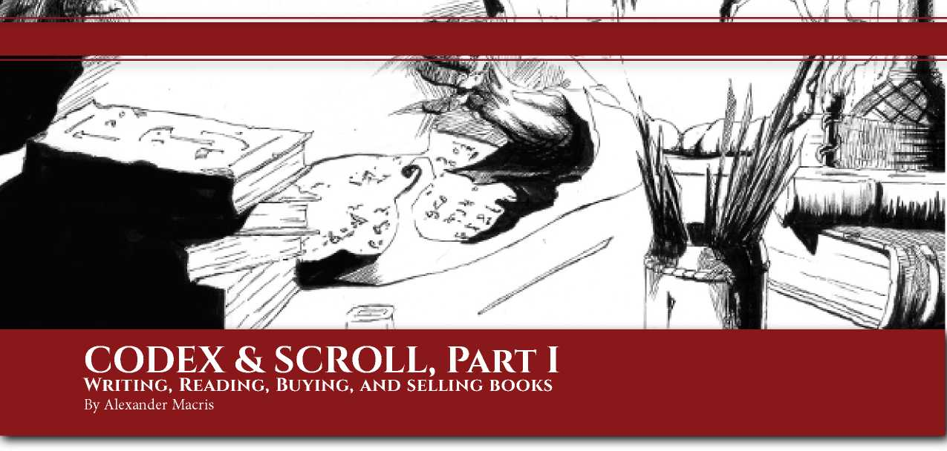*“Within, there were several ponderous brazen-bound volumes of medieval date, a thin manuscript of yellowing parchment, and two portraits whose faces had been turned to the wall, as if it were unlawful for even the darkness of the sealed closet to behold them” —* Clark Ashton Smith, The End Of The Story

An Introduction to Books

Books! Has anything played a more important role in the rise and fall of civilizations? The loss of access to cheap papyrus brought about the destruction of much of classical antiquity’s libraries and helped usher in the Dark Ages. The development of inexpensive paper and the printing press led to the rise of modernity. And everything we know from before, after, and in between is because someone, somewhere, wrote it down.

Yet what do we know about books in *ACKS*? From the *Core Rules* we know that a blank spellbook with 100 pages of parchment costs 20gp and weighs 0.5 stone (Chapter 3). We also know that in order to research a spell, a spellcaster must have access to a library with a minimum value of 4,000gp (Chapter 7) and that a rare book can be found as an item of treasure worth 150gp and weighs 0.5 stone (Chapter 9). From the *Player’s Companion* we know that a holy book of parchment, papyrus, or vellum costs 20gp and grants a +1 bonus to Theology proficiency throws and that a folded parchment or papyrus notebook of 50 pages costs 10gp. And that’s about it... Until now!

Characteristics of Books

A book can be described with the following characteristics:

**Format:** The method by which the book is organized. A book can either be a **codex,** a **scroll roll,** or a **tablet**. A codex is what contemporary readers nowadays call a “book” - a series of pages stitched together between a sturdy protective cover. A typical codex is 12”-13” tall and 9”-10” wide, with a thickness of about 1” per hundred pages (excluding cover) or 1.5” (including cover).

4k

A scroll roll is a length of stitched pages wrapped around a pair of handles and stored in a box or case. A typical scroll roll is 12”-13” tall and 10’-12’ long and consists of about 20 sheets each around 8” wide.

A tablet is an archaic form of book in which words are engraved on metal or clay. A typical tablet is 12” tall and 6” wide and about 1/16” thick and counts as one page.

In any case, a book can be divided into multiple **volumes**, and thus consist of two or more codices, scroll rolls, or tablets.

**Language:** The language that a book is written in. In our real- world Classical and Medieval era, most books were written in Greek, Latin, Persian, or Arabic. In the Auran Empire campaign setting, most books are written in Classical Auran, Ancient Zaharan, or Argoltean.

**Topic:** The specific information contained in a book. For game purposes, the information is described using ranks in **topical proficiencies**. For instance, the topical proficiency in a primer on medicine might be Healing 1, while the topical proficiency in a comprehensive illustrated compendium of all known animal and plant species might be Naturalism 3. A book can have multiple topical proficiencies. A book’s topic can also include sub-specialization within a particular proficiency.

EXAMPLE: The topical proficiency of Plutarch’s *Lives* is Knowledge (history) 2. The topical proficiencies of Columellas *On Agriculture* are Animal Husbandry, Labor J (farming), and Profession (landlord). The topical proficiency | of Aristotle’s *Ethics* is Knowledge (philosophy: ethics) 3.

**Scope:** The total amount of information contained in a book. A book’s scope is the sum of the ranks of all its topical proficiencies. Sub-specializations within a particular proficiency count as one-half of a rank.

EXAMPLE: Plutarch’s *Lives* has a scope of 2. Columella’s *On* J *Agriculture* has a scope of 3. Aristotle’s *Ethics* has a scope of 1.5 - it has three ranks of a sub-specialization of Knowledge (philosophy).

**Complexity:** The difficulty that the book poses to the reader trying to comprehend it. Complexity ranges from 0.25 to 6. A children’s book has a complexity of 0.25. A dramatic or narrative work written with clean prose for an adult audience has a complexity of 0.75. A typical historical work has a complexity of 1. It might have a complexity of 0.75 if presented in a biographical or dramatic format; conversely it might have a complexity of 2 if it presumes a foundation of knowledge that, if absent, makes the work harder to comprehend. (For instance, a history of the Thirty Year’s War that presumes familiarity with the prior history of Europe and the doctrinal differences of the Protestants and Catholics would have a complexity of 2). A typical primer for a branch of knowledge has a complexity of 1. A complete treatise on a branch of knowledge typically has a complexity of 2, or 3 if the author presumes a substantial foundation of knowledge on the part of the reader. An esoteric book that is notoriously difficult to comprehend even for experts in a particular field has a complexity of 4, 5, or (very rarely) 6.

EXAMPLE: Plutarch’s *Lives* has a complexity of 0.75 because of its dramatic, biographical style. Diodorus’ *Library of History* is a straightforward history with a complexity of 1. Columella’s *On Agriculture* is a straightforward treatise on a branch of knowledge and has a complexity of 2. Aristotle’s *Ethics*, though a treatise, assumes an extensive knowledge of* Platonic and Peripatetic philosophy to understand, and has a complexity of 3. Aristotle’s *Organon*, which effectively created the field of syllogistic logic, has a complexity of 4. Hegel’s *The Phenomenology of the Spirit* has a complexity of 5, such that even gifted undergraduate students in philosophy can barely^ understand it. Burkhard Heim’s *Syntrometrische Maximentelezentrik* has a complexity of 6 and no one alive today understands how he unified quantum and gravity... or if he did. You are invited to assess *ACKS* s complexity in the L comments.

**Length:** The number of pages in the book. The length of a book is determined by its scope and complexity, using the formula (scope x 1000) / complexity. Note that, for any given scope, more complex books tend to be shorter. That’s because more complex books omit foundational or low-level material; offer fewer concrete examples; and make less use of wordy techniques such as narrative, analogy, and recap that can make difficult material comprehensible to lesser minds.

EXAMPLE: Plutarch’s *Lives* has a length of (2 x 1000 / .75) **J** 2,667 pages. Columella’s *On Agriculture* has a length of (3 x-j 1000 / 2) 1,500 pages. Aristotle’s *Ethics* has a length of (1.5 x 1000 / 3) 500 pages.

NOTE: The real-world lengths of these books are 2407 pages, 1472 pages, and 329 pages for *Lives, On Agriculture,* and *Ethics* respectively.

**Reading/Reference Time:** The base time required to read and reference the book. Reading time is measured in days of major activity. (A day of major activity represents a 6-hour spans of focused attention, per *Axioms Special Edition 2017: Campaign Activities*). Reference time is measured in turns. The base time required to read or reference a book is the number of pages divided by 180, rounded to the nearest whole number, rounding 0.5 up.

EXAMPLE: Plutarch’s *Lives* has a reading/reference time of (2,667 / 180) 14.8, rounded to 15. Columella’s *On Agriculture* has a reading/reference time of (1,500 / 180) 8.33, rounded to 8. Aristotle’s *Ethics* has a reading/reference/time of (500 / 180) 2.78, rounded to 3. It takes 3 days to read Aristotle’s *Ethics* and 3 turns (30 minutes) to reference it.

NOTE**:** Today the average literate adult can read at 250 words per minute, well-educated readers can comprehend texts at 675 words per minute, and so-called “speed readers” at 1,200 words per minute or more. Reading speeds were much slower in the ancient world. Texts were written with the intent that they would be read aloud, with punctuation and spacing designed with for oration - ifit was present at all. The average literate adult might have read at perhaps 115 to 185 words per minute. Since a typical page might have 250 to 350 words, books were consumed at an average rate of about one page per two minutes. Given 60 minutes per hour and 6 hours per day of reading, that yields (1 page/2 minutes x 60 minutes/ hour x 6 hours/day) 180 pages per day.

**Price:** The value that the book commands in the market, measured in gold pieces. The price ofa 100-page codex ranges from 20gp to 1,000gp or more. The price of a 20-page scroll roll ranges from 4gp to 250gp or more. Clay and stone tablets cost 5sp to 1gp each.

**Weight:** The encumbrance of the book in stone. The encumbrance of a book is determined by its length and construction materials. A typical 100-page codex weighs 1/2 stone. A typical 20-page scroll roll weighs 1/6 stone. A set of 15 clay or 12 stone tablets weighs 1 stone.

Using Books

Reading Books

Any character can attempt to read a book written in a language he knows. Not all books are comprehensible to every reader, however. Reading a book requires one or more day of major activity, depending on the book’s base reading time. The base time required to read a book is modified by the character’s **reading comprehension**. For any given book, a character’s reading comprehension is equal to the character’s INT bonus plus the character’s ranks in the proficiency which is the topic of the book. If multiple proficiencies are the topic of the book, use the character’s lowest rank of any topical proficiency. Compare the character’s reading comprehension to the book’s complexity on the table below.

EXAMPLE #1: Impressarius is a young philosopher with INT 16, Knowledge (philosophy) 2, and Knowledge (history) 1. He would like to read Plutarch’s *Lives* [Length: 2400 pages; Reading Time: 15 Days; Complexity 0.75; Proficiencies: Knowledge (history) 2]*.* His reading comprehension for the book is 2 (INT bonus) + 1 (ranks in the relevant proficiency), for a total of 3. Thai’s greater than three times the book’s complexity, so he can read it in (15 x 33%) 5 days. If Impressarius did not have Knowledge (history), his reading comprehension would only be 2, it would take him 7.5 days to read Plutarch.

EXAMPLE #2: Impressarius loans the book to his friend Mediocritus. Mediocritus has INT 13 and no relevant proficiencies. His reading comprehension is 1 (INT bonus). He can read Plutarch’s *Lives* in the base time of 15 days.

EXAMPLE #3: Mediocritus gives Plutarch’s *Lives* to his unintellectual older brother, Laborious, who has INT 9. Laborious has a reading comprehension of 0. He can read Plutarch’s *Lives* in double the base time, 30 days.

EXAMPLE #4: Laborious pawns the book to his dim-witted comfrey dealer, Ruffianus. Ruffianus has INT 7, granting him a reading comprehension of -1. He cannot make heads or tails of Plutarch. It’s all Greek to him.

Referencing Books

Once a book has been read, a character can thereafter reference it. Referencing a book requires one or more turns, depending on the book’s base reference time. The base time to reference a book is modified by the character’s reading comprehension, as above.

A character referencing a book can make a proficiency throw as if he has gained a rank in one of the book’s topical proficiency, up to a maximum rank limited by the scope of the book. A character can reference a book after having failed a proficiency throw based on his own learned proficiencies or after referencing another book (e.g. he can take a “re-roll”), even if the book can’t increase his rank, but cannot reference the same book twice on the same throw. If a book’s topic is a sub-specializations within a particular proficiency, it can only be referenced for throws related to the sub-specialization.

EXAMPLE: Impressarius wants to know who succeeded Alexander the Great as king of Macedon. The Judge rules that this falls within Knowledge (history). Impressarius has one rank in this his proficiency throw, so he can make a proficiency throw against a target value of 11+. Unfortunately* he rolls a 2, and fails. He decides to reference Plutarch’s *Lives. Lives* has a reference time of 15 turns, reduced by his reading comprehension to 5 turns (50 minutes). After a little under an hour of paging through Plutarch, Impressarius can now make another proficiency throw as if he had gained one rank in d Knowledge (history). At two ranks, his target value is now 7+. He rolls a 9, and succeeds. Had Impressarius already had two ranks in Knowledge (history), Plutarch’s *Lives* could not have raised him to three ranks (because its scope is only 2) but referencing the book would still have allowed him to re-roll.

Working from Books

Once a book has been read, a character may be able to work from it, like a chef working from a cookbook. If a book’s topic is an Art, Craft, Labor, or other proficiency which grants a construction rate, it can be worked from. When working from a book, a character can undertake activities using the book’s topical proficiency at a construction rate of 2sp per day (equivalent to a skilled laborer or about one-half the rate of an apprentice).

| **Comparison of Comprehension to Complexity** | **Effect** |
| --- | --- |
| Reading Comprehension > Complexity x 4 | Book can be read in 25% base time |
| Reading Comprehension > Complexity x 3 | Book can be read in 33% base time |
| Reading Comprehension > Complexity x 2 | Book can be read in 50% base time |
| Reading Comprehension => Complexity | Book can be read in base time |
| Reading Comprehension < Complexity | Book can be read in double base time |
| Reading Comprehension <= Complexity -1 | Book cannot be fruitfully read |

EXAMPLE: Impressarius has read Vitruvius’ *On Architecture*, which has Engineering as its topical proficiency. By working from the book, Impressarius can undertake construction activities at a rate of 2sp per day instead of the usual 1sp per day he would produce as unskilled labor.

Learning from Books

As noted in *ACKS* and clarified in *Axioms 6,* all characters have four implicit general proficiency slots which represent their potential for natural accretion of knowledge over time (in addition to their starting and level-based proficiencies). Characters who are not exceptionally diligent at practice automatically fill these slots after 5, 15, 35, and 70 years of work. Characters can accelerate the rate at which they fill these slots by learning from books.

* It takes 60 days (2 months) of major activity reading books on a particular topic to gain the first rank in the books’ topical proficiency.
* It takes 240 days (8 months) of major activity reading books on a particular topic to gain the second rank in the books’ topical proficiency, or the first rank of a second topical proficiency.
* It takes 540 days (18 months) of major activity reading books on a particular topic to gain the third rank in the books’ topical proficiency, or the first rank of a third topical proficiency.
* It takes 960 days (32 months) of major activity reading books on a particular topic to gain the fourth rank in the books’ topical proficiency, or the first rank of a fourth topical proficiency.

The total time required to gain four proficiency ranks is therefore 1,800 days; at 6 hours per day of major activity that equates to about 10,000 hours. (Characters can use training in lieu of or in combination with reading, as described in *Axioms 6*, if desired, but the total number of proficiencies gained cannot exceed four).

EXAMPLE: Impressarius secures a copy of Columella’s *On^ Agriculture* and decides to learn Animal Husbandry, one of the book’s topical proficiencies. *On Agriculture* has a base reading time of 8 days. Impressarius has a reading comprehension of 2, which is equal to the book’s complexity _ of 2, so it takes him the base of 8 days to read the book. He notes down that he has completed 8 of the required 60 days of major activity to learn Animal Husbandry.

**Overcomplicated Books:** If a book’s complexity exceeds the character’s reading comprehension, he cannot learn from it. Days spent reading the book do not count towards booking learning. Note that because the minimum complexity of a book is 0.25, this means that characters with an INT of 12 or less cannot learn their first rank in a proficiency from a book - they need a teacher.

EXAMPLE: Although Laborious spent 30 days reading Plutarch’s *Lives*, the 30 days do not count towards book learning Knowledge (history). Laborious, with INT 9 and no ranks in Knowledge (history), only had reading comprehension 0 while Plutarch’s *Lives* had complexity 0.75.

**Limit on Reading:** A book with a complexity of 1 or less can only be read once for purposes of book learning. A book with a complexity of 2 or more can be read multiple times for purposes of book learning, to a maximum number of times equal to its complexity.

EXAMPLE: If Impressarius reads *On Agriculture* a second 1 time, it counts towards another 8 days of major activity to j learn Animal Husbandry. If he reads it a third or fourth time, the book provides no further benefit.

**Fast Readers:** Characters whose reading comprehension would normally allow them to read a book faster can read it at a slower speed in order to capture its full value towards learning.

**Retraining:** Characters in *ACKS* can retrain an existing class or general proficiency for another proficiency of the same type with 120 days of major activity. The character must have access to a tutor who knows the proficiency, or - more relevant to our purposes here - to one or more books with a topical proficiency of the appropriate proficiency rank. A character can re-learn a proficiency he previously knew with 60 days of study.

Writing, Copying, & Translating Books

Writing Books

Any character with INT 9 or higher can write a book on a topic for which he has at least one proficiency rank. Writing a book is a major activity, during which time a character can write one page per day. The ranks of the book’s topical proficiencies cannot exceed the character’s ranks in those proficiencies. The complexity of the book cannot exceed the character’s reading comprehension in the topic. A character writing a book must still pay, or get someone else to pay, its material costs (see below).

EXAMPLE: Impressarius has INT 16 and ranks in — Knowledge (philosophy) 2 and Knowledge (history) 1. He decides to write a new book, *Commentaries on Plutarch*, with the topic Knowledge (history). The scope of the book cannot exceed Knowledge (history) 1 because Impressarius has only one rank in the topic. The complexity of the book cannot exceed 3, his reading comprehension in the topic (INT bonus +2 and proficiency +1). Impressarius decides he is writing for a literate audience and selects a complexity of 2. *Commentaries on Plutarch* will therefore be (1000 pages x j scope 1 / complexity 2) 500 pages. It will require 500 days of writing to complete. If Impressarius writes 25 days per month, he will complete the book in 20 months. 1

NOTE: After a lifetime of writing, Aristotle’s complete works tallied to 1256 pages while Shakespeare’s complete works reached 2700 pages. It took St. Thomas Aquinas just eight years to write the 3500-page *Summa Theologica,* writing at an average of 437 pages per year*.* We assume that most authors do not share the Angelic Doctor’s inspiration, and write at most 300 pages per year (1 page per day, 25 days per month, 12 months per year).

Copying or Translating Books

A literate character can copy the text of an existing book at a rate of one page per day, plus one page per rank in Art (calligraphy) or Craft (scribing). Thus the average scribe with two ranks in Craft (scribing) or Art (calligraphy) can copy the text of an existing book at a rate of three pages per day. A character can translate a book from one language to another at a rate of one page per day. A character copying a book must still pay (or get someone else to pay) its **production cost** (see below).

NOTE: The Bible is around 1,200 pages long. It required about 1.25 years (15 months) for a new copy of a Bible to be scribed from an existing version. 1,200 pages at 15 months per copy at 25 days copying per month yields a rate of 3.2 pages per day, which we have rounded to 3 pages per day.

Hiring Specialists

A character can hire a specialist to write, copy, or translate a book. The minimum cost per page is shown below. Remember that the writer’s rank in each topical proficiency must equal or exceed the book’s ranks in the same.

|  |  |
| --- | --- |
| **Proficiency Rank** | **Cost per Page** |
| Writer, Rank 1 | 1gp |
| Writer, Rank 2 | 2gp |
| Writer, Rank 3 | 4gp |
| Writer, Rank 4 | 10gp |
| Copyist | 2sp |
| Translator | 1gp |

**Gifted Writers:** Some complex books can only be written by a gifted writer, e.g. one with an INT bonus of +1, +2, or +3. Gifted writers are more expensive. Subtract the book’s scope from its complexity. If the result is at least 1, increase the cost per page by 25%. If the result is at least 2, increase the cost per page by 100%. If the result is at least 3, increase the cost by 400%.

EXAMPLE: Hegel’s *Phenomenology* contains Knowledge (metaphysics) 3, with a cost per page of 4gp. However the book has a complexity of 5. Subtracting its scope of 3 from its complexity of 5 yields a result of 2. Only a gifted writer with INT 16 or more (+2 bonus) could write the book. Therefore its cost per page is increased by 100% to 8gp.

NOTE: The cost per page for writing is based on the monthly wage of a professional (25gp, 50gp, 100gp, or 250gp) x 12 months per year / 300 pages per year. The cost per page for copying is based on the monthly wage of an artist with two ranks (20gp) x 12 months per year / 1080 pages per year. The cost increase for complexity uses the same formula that increase in value for high ability scores uses in *Lairs & Encounters* (+25% for 13-15, +100% for 16-17, +400% for 18).

Producing Books

The production of books is an expensive and time-consuming process. The exact cost depends on the format, length, construction material, and other criteria.

**Production, Simplified:** A book costs at least 3sp per page, or 2sp per blank page. It can cost as much more as desired.

Selection of Page Materials

Most books are written on parchment or papyrus, though other materials are available. Codices may be written on parchment or metal foil. Scroll rolls may be written on papyrus or parchment. Tablets may be written on metal foil, clay, or stone. For purposes of book encumbrance, treat 1 stone as 15 lbs.

NOTE: Historically, it required the hides of 120 sheep to provide enough parchment for a codex of 480 pages. Therefore, each sheep hide provides parchment for four pages. A typical sheep in *ACKS* weighs 80 lbs. According to *Lairs & Encounters,* the value in gp of a sheep hide is .00265 x weight in lbs. Therefore an 80 lbs sheep’s hide is worth 0.212 gp, or 21cp. 21.2cp / 4 = 5.3cp. Is that a historically plausible price? Yes. According to *The Cost of Books in Chaucer’s Time* by Wilbur Lang Schram (Modern Language Notes, p. 139­145, vol. 48, no. 3, Mar., 1933), parchment sold for 3 to 6 silver pennies per eight pages. Since *ACKS* equates a 13th century silver penny with a silver piece, the historical price would be 3sp to 6sp per eight pages, or 3.75cp to 7.5cp per page. Our bottom-up price based on sheep hides thus falls midway between this range. Glorious!

**Lifespan:** Most writing materials eventually deteriorate due to mold. Lower quality material deteriorates more quickly. However, the lifespan of papyrus and parchment can be indefinite if kept in a warm, dry environment. In the Auran Empire campaign setting, papyrus is used in the dryer climates of Kemesh, Opelenea, Nicea, western Tirenea, and southern Krysea, while parchment is more common in Celdorea, Jutland, Rorn, and the Argoltes. Since most campaigns only last a few years of game time, lifespan has little effect on adventurers, but a Judge who seeks verisimilitude may keep it in mind when placing books and scrolls in his dungeons.

**Exotic Parchments:** While parchment was historically made from sheep, goat, or cow, in a fantasy world more exotic parchments are possible at the Judge’s discretion. A creature yields one page worth of hide per 20 lbs of weight. The cost per page is equal to the creature’s value x2 divided by its weight.

| **Page Material** | **Cost / Page** | **Weight/Page** | **Lifespan** | **Format** |
| --- | --- | --- | --- | --- |
| Papyrus, coarse, 0.01” thick | 1cp | 0.06 lbs | 10 years | Scroll Roll |
| Papyrus, ordinary, 0.01” thick | 2cp | 0.06 lbs | 30 years | Scroll Roll |
| Papyrus, fine, 0.01” thick | 3cp | 0.06 lbs | 50 years | Scroll Roll |
| Parchment, coarse, 0.01” thick | 4cp | 0.06 lbs | 100 years | Codex or Scroll Roll |
| Parchment, ordinary, 0.01” thick | 6cp | 0.06 lbs | 500 years | Codex or Scroll Roll |
| Parchment, fine (vellum), .01” thick | 8cp | 0.06 lbs | 1,000 years | Codex or Scroll Roll |
| Copper foil, .005” thickness | 12cp | 0.12 lbs | Indefinite | Codex or Tablet |
| Silver foil, .005” thickness | 15sp | 0.15 lbs | Indefinite | Codex or Tablet |
| Gold foil, .005” thickness | 30gp | 0.30 lbs | Indefinite | Codex or Tablet |
| Clay tablet, 0.125” thickness | 5sp | 0.75 lbs | Indefinite | Tablet |
| Stone tablet, 0.125” thickness | 1gp | 1 lbs | Indefinite | Tablet |

EXAMPLE: An angry dwarven craftpriest decides that his book on woodcutting will have pages of treant bark paper. According to *Lairs & Encounters,* a treant weighs 3,185 lbs and is worth 20,250gp. The cost per page of treant bark paper is therefore (20,250 x 2 / 3185) 6.35gp.

Production of Codices

A codex consists ofa series of pages stitched together between a sturdy protective cover. A typical codex is 12”-13” tall and 9”-10” wide, with a thickness of about 1” per hundred pages (excluding cover) or 1.5” (including cover). A codex can have up to 750 pages. Books of more than 750 pages must be split into multiple volumes.

The format ofa codex is not accidental. Papyrus is too fragile to be folded, bent, and stitched, so parchment must be used in codices. However, parchment is prone to warp and ripple with humidity. Thus the medieval codex’s heavy wooden cover, clamped tightly with leather straps or metal clasps, is a functional necessity to keep the parchment pages flat.

Leather- or cloth-bound codices become difficult to read after 10 years due to warping (double base reading time).

Costs shown are minimums. There is no effective maximum to the treasure that can enhance a codex. Choose one cover, one clasp, and one strap.



Production of Scroll Rolls

A scroll roll is a length of stitched pages wrapped around a single handle or pair of handles and stored in a box, case, or jar. A typical scroll roll is 12”-13” tall and consists of about 20 pages, each about 8” wide, glued or stitched together to form a continuous length about 12’ long. A scroll roll can have up to 125 pages with one handle or up to 250 pages with two handles. Longer books must be split into multiple volumes, each with its own handle or handles.

Costs shown are minimums. There is no effective maximum to the treasure that can enhance a scroll roll. Choose one or two handles and one case.

| Cover, leather or cloth | 1sp+ | 0.5 lbs | After 10 years reading time doubles |
| --- | --- | --- | --- |
| Cover, wooden, %” thick | 1sp+ | 1.5 lbs |  |
| Cover, wooden, %” thick, leather-wrapped | 2sp+ | 1.5 lbs |  |
| Cover, treasure bound (gold, ivory, etc.) | 1gp+ | 2 lbs |  |
| Cover clasp, brass or bronze | 5cp+ | N/A |  |
| Cover clasp, silver | 5sp+ | N/A |  |
| Cover clasp, gold | 5gp+ | N/A |  |
| Cover straps, leather | 1cp+ | N/A |  |
| Cover straps, silk | 1sp+ | N/A |  |

Weight Notes

Page Material Cost

Scribing, Illuminating, and Binding Books Book scribing, illuminating, and binding are time consuming and expensive. It costs 2sp per page to have a book professionally scribed and takes 1 day per 3 pages. (If the book’s writer is himself a scribe, he will have scribed it while writing. If the book was professionally copied in the first place, this cost and time has already been paid.) It costs 1sp per page to have it illuminated and takes 1 day per 6 pages. (Additional sums can be spent on illumination if desired, with no upper limit.) It costs 1cp per page to have a codex bound and takes 1 day per 32 pages (for simplicity, 1 day per 100 pages).

**Shoddy Workmanship:** Careful scribing and illumination are essential to the readability of a book by those other than its writer. A book that has not been professionally illuminated has double the base reading time when read by others, and a book that has not been scribed or illuminated professionally has triple the base reading time when read by others.

|  |  |  |
| --- | --- | --- |
| Service | Cost | Time Required |
| Book Scribing | 2sp/page | 1 day per 3 pages |
| Book Illuminating | Isp/page | 1 day per 6 pages |
| Codex Binding | 1cp/page | 1 day per 32 pages |

Producing a Book:

Commentaries on Plutarch

Impressarius has completed a manuscript of his 500-page *Commentaries on Plutarch.* It’s now time to transform it into a book for the university library. He decides on a codex format with ordinary parchment pages, a leather-wrapped wood cover with brass cover clasp and leather straps, all professionally scribed, illuminated, and bound. The costs and time are shown on the table below.

NOTE: Is this price historically plausible? The article *“The Cost of Books in Chaucer’s Time”* offers the following example: “Suppose a manuscript covered thirty quires (240 pages). His paper would cost 7s 6 d. He would have to pay the scribe 40s. A modest illumination would cost 1 l. A very respectable binding could be had for 10 s. The total is 77s 6 d.” Since *ACKS* sets a 13th century silver penny (d) at 1 silver piece, that is (77s x 12sp/s) + (6dx 1sp/d) = 924sp + 6sp = 930sp, or 93gp for a book of 240 pages. 185gp for a book of 500 pages is thus eminently plausible.

Valuing Books

A typical book will be worth no more than it costs to produce, but a rare book can be worth much more. To determine the value of a book, follow these steps:

1. Calculate how much the book would cost to write, using the rules found in Writing Books and the costs noted under Hiring Specialists. This is the book’s **base literary value**.
2. Determine how many copies of the book are in existence and multiple the book’s base literary value by the rarity modifier. This is the book’s **modified literary value**.
3. Calculate how much the book cost to produce using the rules and costs found in Producing Books. This is the book’s **production value**.
4. The book’s **market value** is the sum of its modified literary value and its production value.

Rarity Modifier

The more widely available a book is, the less it is worth. The holy book of a civilization will be widely available, with 5,000 to 15,000 or more copies extant. A popular book will have 1,000 to 5,000 copies in existence. Well-known and highly cited books will have between 100 and 1,000 copies extant. Rare books found as treasure will number less than 100 copies.

|  |  |
| --- | --- |
| Number of Copies Extant | Rarity Modifier |
| 1 | 100% |
| 2 to 5 | 50% |
| 6 to 25 | 33% |
| 26 to 50 | 25% |
| 51 to 100 | 10% |
| 101 to 250 | 5% |
| 251 to 500 | 2% |
| 501 to 1000 | 1% |
| 1,000 or more | 0% |

Valuing a Book:

Commentaries on Plutarch

How much is Impressarius’ book *Commentaries on Plutarch* actually worth? According to the *ACKS* treasure tables, a generic rare book is worth 150gp per У2 stone. Since *Commentaries* is 2 1/6 st, we’d expect it to be worth 650gp. Of course we wouldn’t expect every rare book to be worth exactly that.

| Ordinary parchment pages | 6cp/p. x 500 p. = 30gp | .06 lbs/p. x 500 p. = 30 lbs | N/A |
| --- | --- | --- | --- |
| Wooden leather-wrapped cover | 2sp | 1.5 lbs | N/A |
| Brass cover clasp | 1sp | N/A | N/A |
| Leather straps | 1cp | N/A | N/A |
| Book Scribing | 2sp/p. x 500 p. = 100gp | N/A | 165 days |
| Book Illuminating | 1sp/p. x 500 p. = 50gp | N/A | 83 days |
| Codex binding | 1cp/p. x 500 p. = 5gp | N/A | 15 days |
| **Total** | **185gp, 3sp, 1cp** | **31.5 lbs (2 1/6 st)** | **263 days** |

Factors of Production

Cost

Weight

Time

Let’s start at the moment of its creation. It is a 500-page work with a topical proficiency of Knowledge (history) and a complexity of 2. The cost per page would therefore have been 1gp (for a rank 1 writer) + 2.5sp (25%, because it would have a required a gifted writer, since its complexity exceeded its rank). The book’s base literary value is therefore (500 pages x 1.25gp/page) 625gp. There is only one copy of the book in existence, so its rarity modifier is 100%. Therefore its modified literary value is still 625gp. Its production value (from above) is 185gp, 3sp, 1cp. Therefore *Commentaries on Plutarch* has a total value of 810gp, 3sp, 1cp.

What if there are copies? Let’s imagine that Impressarius becomes a famous scholar, and that his book *Commentaries on Plutarch* is copied and distributed to about a dozen universities. Now its rarity modifier is 33%, so its modified literary value is (625gp x 33%) 206gp, 2sp, 5cp. Its total value is 391gp, 5sp, 6cp.

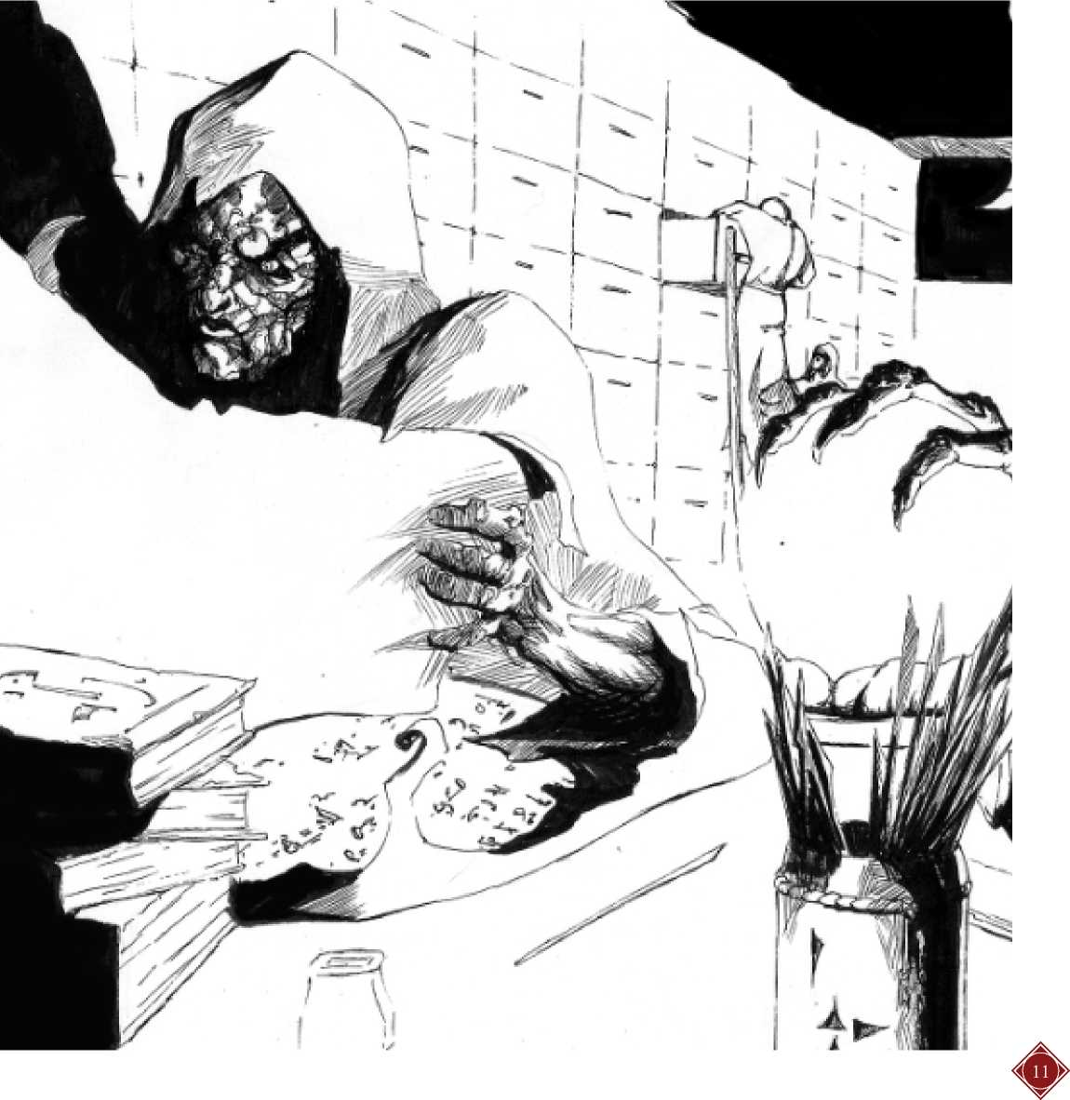So *Commentaries* might be worth between around 390gp to 810gp, a nice spread within which 650gp seems quite reasonable

*It is well known, that the ancient wise Men and Philosophers, very seldom set forth the naked and open Truth; but exhibited it veiled or painted after various manners; by Symbols, Hieroglyphicks, Allegories, Types, Fables, Parables, popular Discourses, and other Images. This I pass by in general as sufficiently known. -* Thomas Burnet, Archcvologkv Philosophic^

**CODEX & SCROLL, Part II**

**libraries & Authorities**

By Alexander Macris

of users may be limited by the **capacity** of the library (see below).

Collections and Libraries of Books

A **collection** is a set of one or more books. A **library** is a set of one or more collections of books. The **research value** of a collection is equal to the sum of the market value of all the books contained within it. The research value of a library is equal to the sum of the market value of all the collections contained within it.

NOTE: Why market value instead of literary value? Many reasons! First, using market value allows us to avoid having to track two values for every copy of every book. Second, it avoids having to worry about “double counting” books in a library; if a library has many copies of a particular book, its widespread availability will already be reflected in its market value. Third, it helps simulate the importance that the ancients put on proper scribing and illumination when evaluating a book’s usefulness. Fourth, because market value includes rarity, it reflects the fact that the knowledge most sought in a library is that which isn’t already widely known. Information which is contained in highly-circulated books is precisely the knowledge that proficient characters are most likely to already know and is thus “worth less” for research. For all these reasons, we recommend using the market value rather than literary value for library.

A collection or library may be **exclusive** and used by only one character, or it may be **shared** by several characters. The research value of a shared collection or library for each user is equal to its total research value divided by the number of characters actively using it, rounded down. The total number EXAMPLE: Quintus has built up a small library with a research value of 17,000gp. If Quintus is the exclusive user of his library, it has its full research value. If Quintus shares his library with two apprentices, its research value is (17,000gp / 3 users), or 5,666gp per user. If Quintus shares his library with his entire twelve-person guild, the value of the library to each user would be (17,000gp / 12 users), or 1,416gp.

Many libraries consist of just one collection and in that case the terms are synonymous. But sometimes a library may be segmented into different collections, with varying degrees of access to the various collections afforded to different characters. In this case, calculate the research value of each collection separately based on the number of characters actively using that collection. Each character is then provided with a library research value equal to the total research value of all ofthe collections he can access. By carefully segmenting the library into collections, wizard’s guilds and temples can service many low-level characters while still ensuring high- level characters have access to sufficiently high research values for their needs.

EXAMPLE: Quintus has increased the value of his library to J 76,000gp. He now divides it into three collections. His public collection has books on arts, crafts, history, and philosophy worth 48,000gp. His public collection is shared with his entire guild (12 characters, most 1st or 2nd level). His private collection has books on astrology, physics, and theology worth 16,000gp. The private collection is used by Quintus, his friend Balbus, and their two 5th-level apprentices. His secret collection has books on black magic and occult matters worth 12,000gp; only Quintus and Balbus have access to this collection.

The public collection has a research value of (48,000gp /12 users) or 4,000gp. The private collection has a research value of (16,000gp / 4 users) 4,000gp. The secret collection has a research value of (12,000gp / 2 users) 6,000gp.

The public collections users have individual research values of 4,000gp each, enough for 1st level spells. The apprentices with access to the public and private have research values of (4,000gp + 4,000gp), or 8,000gp, enough for 3rd level spells. Balbus and Quintus have research values of (4,000gp + 4,000gp + 6,000gp), 14,000gp total, enough for 6th level spells.

What if the libraries were consolidated? With 12 users with equal access, everyone would have a research value of (76,000gp / 12 users) 6,333gp - enough for 2nd level spells only. This would be more than the 1st and 2nd level guild members need, and less than the higher-leveled characters need.

The following guidelines can be used to asses the space required for a library of known research value:

* Classical library with scrolls: 1 cubic foot per 130gp or per 0.864 scrolls
* Medieval library with codices: 1 cubic foot per 180gp or per 1.2 codices
* Mixed library of codices and scrolls: 1 cubic foot per 150gp or per 1 book (cool, eh?)

NOTE: Here’s the assumptions that drove our guidelines above. First, assume the average scroll roll is 12.5” tall with 4”-tall handles increasing its height to 16.5”. Its 100 stitched pages are wrapped around the handle to yield a rolled diameter of approximately 4”. Nine scroll rolls are secured inside a scroll box measuring 18” wide, 12” tall, and 12” deep. Assume that groups of these scroll boxes are stored on bookcases that are 7’ tall, 7’ wide, and 15” deep. Give each bookcase a set of six shelves with interior dimensions of 13” height, 12” depth, and 75” width. Then each shelf can hold 4 scroll boxes of 9 scroll rolls, or 36 scroll rolls per shelf; and each bookcase can hold 24 scroll boxes, or 216 scroll rolls total. Four such bookcases can be fit back to back into each 10’ x 10’ x 10’ volume of space with a 2.5’ wide interval between each pair of bookcases. Therefore a library can contain 864 scroll rolls per 1,000 cubic feet. At 150gp per scroll roll, 864 scroll rolls have an average value of 129,600gp while taking up 1000 cubic feet, or 1 cubic foot per 130gp.

Now, assume the average codex has the following dimensions: 12.5” height, 10” width, 1.5” spine thickness, and У2 stone weight. Assume that groups of these codices are stored spine- out on bookcases that are 7’ tall, 7’ wide, and 1’ deep. Give each bookcase a set of six shelves with interior dimensions of 13” height, 11” depth, and 75” width. Then each shelf can hold 50 codices, and the bookcase can hold 300 codices total. Four such bookcases can be fit back to back into each 10’ x 10’ x 10’ volume of space with a 3’ wide interval between each pair of bookcases. Therefore a library can contain 1200 codices per 1,000 cubic feet. The *ACKS Core Rules* assume a book weighing У2 stone has an average value of 150gp. 1200 % stone codices therefore have an average value of 180,000gp while taking up 1000 cubic feet, or 1 cubic foot per 180gp.

EXAMPLE #1: Orosios, in his *History Against the Pagans*, claims the Library of Alexandria had 400,000 separate scrolls. While this number is most likely exaggerated, let’s assume it is real. If each scroll is worth 150gp, the Library of Alexandria had a research value of 60,000,000gp. Since it was a classical library, it would require 60,000,000gp x 1 cubic foot / 130gp or 461,538 cubic feet. (We could calculate this as 400,000 scrolls x 1 cubic foot / 0.864 cubic feet per scroll, too.) The Library of Alexandria might have measured 124’ long, 124’ wide, and 30’ tall. Certainly a large building, but well within the capacities of the ancients.

EXAMPLE #2: The New York Public Library on 42nd and 5th contains about 12,000,000 books, or thirty times more than the Library of Alexandria. At 1 cubic foot per 1.2 codices, we calculate its size should be about 10,000,000 cubic feet. And, in fact, the New York Public Library is 390’ long, 270’ wide, and 98’ high, totaling 10,391,400 cubic feet.

EXAMPLE #3: The Widener Library at Harvard (within whose dusty stacks your author once researched his very first wargame) contains 3.6 million books. At 1 cubic foot per 1.2 codices, we calculate its size should be about 3,000,0000 cubic feet. The Widener Library building is 250’ long, 200’ wide, and 80’ high, for a total of 4,000,000 cubic feet. We presume the surplus 1,000,000 square feet holds the secret vault where the Necronomicon is kept.

Capacity of Libraries

The maximum number of characters that can use a library is limited by its **circulation capacity** and **seating capacity**. Circulation capacity is based on the quantity and quality of books available to researchers. It is equal to the library’s research value divided by 1,500gp. Most libraries will never reach circulation capacity.

Seating capacity is based on the physical space available to users. Any library has spaces between its bookcases where lecterns, stools, or small reading tables might fit between the bookshelves. If no other accommodations are made, then a library’s seating capacity is equal to 1 + the library’s volume divided by 1,500 cubic feet, rounded down. If desired, the builder of a library can set aside dedicated reading rooms with long tables, monastic study cells, rows of lecterns, or other arrangements. A dedicated reading room increases seating capacity by 1 per 350 cubic feet (i.e. 35 square feet per story).



EXAMPLE #1: The Library of Alexandria has a circulation capacity of (60,000,000gp / 1,500gp) 40,000 users. However, it has a seating capacity of only 1 + (461,538 cubic feet / 1,500 cubic feet) 308 users unless dedicated reading space is set aside. Imagine that the pharaoh builds a fourth floor reading room. If it measures 124 x 124 x 10, it would be 153,760 cubic feet and could seat 440 more users, bringing the seating capacity to 748. These 748 users would each enjoy a research value of (60,000,000gp / 748) 80,213gp - enough to gain a +3 bonus on research for even 9th level spells. It’s no surprise this valuable building suffered a series of Arson hijinks.

EXAMPLE #2: Quintus has built a 76,000gp library. It includes a mix of codices and scrolls, and takes up (76,000gp / 150gp) 507 cubic feet in his stronghold. It has a circulation-< capacity of (76,000gp / 1500gp) 50 users. It has a seating capacity of 1 + (507 cubic feet / 1500 cubic feet) 1.34 users, rounded to 1. Since Quintus wants his library to be useful to his entire guild (12 members), it will require a dedicated reading room. He notes that (11 seats x 350 cubic feet/seat) 3,850 cubic feet of reading room. Thus Quintus needs (507 cubic feet + 3,850 cubic feet) 4,357 cubic feet for his library. This could be built as a 10’ x 5’ x 10’ “stack” (bookcase area) and a 20’ x 20’ x10’ reading room. He might also adopt a more creative layout reflecting the division of his library into three collections.

**-U ■ z/ — —**

EXAMPLE: Assume that Plutarch’s *Lives* consists of 12 volumes of 200 pages each. If Impressarius has a partial copy with 7 of the 12 volumes, his percentage of completeness is 58%. Plutarch’s *Lives* has a reading time of 15 days and a scope of 2. Impressarius’ partial copy has a reading time of (15 x 58%) 8.7 days, which rounds to 8.5 days. It has a scope of (2 x 58%) 1.16, which rounds to 1. The complete book *Lives* contains Knowledge (history) 2, so Impressarius’ partial copy Д contains Knowledge (history) 1. At the Judge’s discretion, he could rule that Impressarius’ copy contains two ranks in a sub-specialization such as Knowledge (history of the Macedonian Conquest and Succession Wars).

Where relevant, collections with a library can be allocated Researching in Libraries capacity using the same rules. For instance, a restricted access The primary in-game use of libraries is spell research. A

collection might have its own area. character must have access to a library with a minimum

research value of 4,000gp to research 1st level spells. The required research value is increased by 2,000gp for each subsequent spell level.

Having access to an exceptionally valuable library aids research. For every 10,000gp of research value above the minimum required for the spell, the researcher receives a +1 bonus on his magic research throw (up to a maximum +3 bonus).

Increasing the Size of Libraries

Every time a character successfully researches a spell, 10% of the gold spent for that effect is added to his library’s research value, reflecting the value of notes and annotations made during research. These notes can kept for use in the character’s private library, or added to a shared collection.

Volumes of Books

Using Books with Missing Volumes or Pages Sometimes, a character or library may possess only some or one of the volumes that make up a book. Other times all the volumes may be available but some volumes may be missing pages. Sometimes both problems can occur! When a book is missing volumes or pages, it is less useful.

When using a book with missing pages or volumes, find the **percentage of completeness** by dividing the number of available pages or volumes over the total number of pages or

ACCeSS tO Libraries volumes. Multiply the book’s reading time and scope by the

A guild, monastery, temple, library, museum, or other place percentage of completeness. Round any fractions down to the

of learning might charge a monthly or daily fee to characters nearest 0.5. If the book has only one topical proficiency, then

seeking to access their library. The monthly fee is equal to the reducing the scope will reduce the rank of the book’s topical

user’s research value / 400. The daily fee is equal to the user’s proficiencies. At the judge’s discretion, two ranks in a

research value / 8000. The fee can be segmented by collection. proficiency might be reduced to two ranks in a sub­

specialization, and one rank in a proficiency might be EXAMPLE #1: If the Library of Alexandria charged for reduced to one rank in a sub-specialization.

access, each of its 748 members would have to pay (80,213gp / 400) 200gp per month or (80,213gp / 8000) 10gp per day.

EXAMPLE #2: Quintus decides to charge for access to his library. His public collections users have individual research values of 4,000gp each, so the monthly fee is (4,000gp / 400) 10gp. The private collections users have research values of 8,000gp, so their monthly fee is 20gp. The secret collection’s users have research values of 14,000gp, so their monthly fee is 35gp. The daily fees would be 5sp, 1gp, and 1.75gp respectively.

Maintenance of Libraries

A library with a value of 60,000gp requires a librarian.

If the book has multiple topical proficiencies, the Judge should allocate the lower scope across the topical proficiencies as best seems appropriate. The rank of at least one topical proficiency should be reduced by at least one in any book with missing volumes.

Valuing a Volume

In most cases, the market value of a volume in a book is simply the market value of the book divided by the number of volumes in the book.

EXAMPLE: The 2,400-page Plutarch’s *Lives* is widely available, with more than one thousand copies available. Its modified literary value is therefore 0. Assume its production value is 3,120gp (13sp per page x 2,400 pages, covering copying, illumination, and binding). If the book consists of 12 volumes of 200 pages each, then each volume costs (3,120gp / 12 volumes) 260gp.

Sometimes, however, a book might have many volumes that are widely circulated, while a few are very rare or even secret. In this case, the market value of the book should be calculated twice - first using the rarity modifier of the common volumes, and second using the rarity modifier of the rare volume(s). The market value of each of the common volumes is equal to the book’s first (common) market value divided by the total number of volumes. The market value of each of the rare volumes is equal to the book’s second (rare) market value minus the market value of all the common volumes, divided by the number of rare volumes. The market value of a complete book will be based on the rarest volume when using this system.

EXAMPLE: Assume that there are a thousand copies circulating of volumes I to X of Plutarch’s *Lives,* but only five copies exist anywhere of volumes XI and XII. Since it contains Knowledge (history) 2 at complexity 0.75, the literary value of *Lives* is 2gp per page, or 4,800gp. The rarity modifier for volumes I to X is 0%, while for volumes XI to XII it is 50%. As above, the production value is 3,120gp. The book’s common market value is therefore 3,120gp while its rare market value is 3,120gp + (50% x4,800gp) or 5,520gp. With these totals we can calculate the value per volume.

The value of each common volume I to Xis (3,120gp /12 total volumes) or 260gp. The market value of all the common volumes is (260gp/common volume x 10 common volumes) 2,600gp. The value of each rare volume XI and XII is [(5,520gp - 2,600gp) / 2 rare volumes] or 1,460gp each. The total market value of Plutarch’s *Lives* is (260gp/common volume x 10 common volumes) + (1,460gp/rare volume x 2 rare volumes) or 5,520gp.

Esoteric Books

An **esoteric book** is one that has a surface meaning for general readers and a hidden meaning that can be comprehended only by a reader of sufficient intelligence and determination who follows the hints, suggestions, and purposeful errors sprinkled throughout the text. Although the two are often confused for each other, an esoteric book is the opposite of an allegorical book: An allegorical book uses metaphorical techniques to *reveal* a message within a text, while an esoteric book uses metaphorical techniques to *conceal* a message within a text. Aesop’s *Fables* is allegorical, while Plato’s *Republic* is esoteric. *Chronicles of Narnia* is allegorical, and *The Lord of the Rings* is esoteric.

The reasons why a writer may create an esoteric book can vary. It may be commitment to esoteric religious doctrine; to avoid accusations of apostasy, atheism, or heresy; or to protect a culture’s “noble lies” from exposure to the people.

Characteristics of Esoteric Books

An esoteric book has two different categories of topics, **apparent topics** and **esoteric topics**. The apparent topic is what the book superficially seems to be about, while the esoteric topic is what the book is secretly about. Sometimes the topic is the same, but the esoteric topic expands upon the apparent topic. The two different topics have different scopes, the **apparent scope** and **esoteric scope**; and two different complexities, the **apparent complexity** and **esoteric complexity**. The only necessary relationship between the two is that (apparent scope / apparent complexity) must equal or exceed (esoteric scope / esoteric complexity).

EXAMPLE: Plato’s *Republic* has the apparent topic Knowledge (political theory: constitutions) 2. It has an apparent scope of 1 and an apparent complexity of 2. It has_ the esoteric topic of Knowledge (philosophy) 2, with the esoteric scope of 2 and an esoteric complexity of 4. The J apparent scope / apparent complexity is 1/2, or 0.5, which - equals the esoteric scope over esoteric complexity is 2/4, or 0.5.

The **length** and **reading time** of an esoteric work are based on its apparent scope and apparent complexity. Note that the esoteric scope and complexity do not add to the length and reading time; it is “hidden” in the work.

EXAMPLE: Plato’s *Republic* has a length of 1000 pages x 1 scope / 2 complexity = 500 pages. It has a base reading time of 2.78 days, rounded to 3 days. |

Using Esoteric Books

An esoteric book appears, on casual inspection, to be about its apparent topic and the character’s apparent reading comprehension uses the character’s INT bonus plus rank(s) in the apparent topic.

Apparent Comparison Effect

|  |  |
| --- | --- |
| Reading Comprehension > Complexity x 4 | Apparent book can be read in 25% base time |
| Reading Comprehension > Complexity x 3 | Apparent book can be read in 33% base time |
| Reading Comprehension > Complexity x 2 | Apparent book can be read in 50% base time |
| Reading Comprehension => Complexity | Apparent book can be read in base time |
| Reading Comprehension < Complexity | Apparent book can be read in double base time |
| Reading Comprehension <= Complexity -1 | Apparent book cannot be fruitfully read |

However, when the character begins reading an esoteric book, the Judge should secretly calculate the character’s esoteric reading comprehension using the character’s INT bonus plus rank(s) in the esoteric topic. If the character’s esoteric reading comprehension is high enough to notice the esoteric topic, he can decide to read the book esoterically. A book must be read for its apparent and esoteric topics separately.

|  |  |
| --- | --- |
| **Esoteric Comparison Effect** | |
| Reading Comprehension => Complexity x 2 | Esoteric book can be read in base time |
| Reading Comprehension => Complexity | Esoteric book can be read in double base time |
| Reading Comprehension < Complexity | Esoteric book is noticed but cannot be fruitfully read |
| Reading Comprehension <= Complexity -2 | Esoteric book is unnoticed by character |

EXAMPLE: Impressarius is a young philosopher with INT 16, Knowledge (philosophy) 2, and Knowledge (history) 1. He decides to read Plato’s *Republic*. He knows nothing of political theory, so his apparent reading comprehension is (2 + 0) 2. Thai’s equal to the apparent complexity of 2, so he is able to read Plato’s *Republic* with its base reading time of 3 days*.* As he begins to read the book, the Judge secretly assesses whether Impressarius notices the esoteric topic. Impressarius’ esoteric reading comprehension is (2 + 2) 4, which is equal to its esoteric complexity of Plato’s *Republic,* so not only does he notice it, he can choose to read the book esoterically at double its base reading time.

What if Plato’s *Republic* were written with an esoteric complexity of 5? In that case, Impressarius’ esoteric reading comprehension would be lower than the esoteric complexity by 1 point. He’d notice that there was something esoteric, but he wouldn’t be able to fruitfully read it.

What if Plato’s *Republic* were written with an esoteric complexity of 5, and Impressarius had only one rank in Knowledge (philosophy), giving him an esoteric reading comprehension of 3? In this case, Impressarius would be entirely unaware of the book’s esoteric nature. He’d simply think Plato was offering up a hypothetical constitution for a polis, and it would fall to his distant ancestor Leo Strauss to sort things out.

Even if personally unable to ascertain a book’s esoteric topic, a character may know it is an esoteric book by reputation. A character can make an appropriate Loremastery, Art, Knowledge, Craft, or similar proficiency throw to identify that a particular book on a particular topic is known to be esoteric.

Writing Esoteric Books

A character must have an INT 18 in order to write an esoteric book. Lesser minds are simply not up to the task. The rank of the book’s apparent and esoteric topical proficiencies cannot exceed the character’s rank in those proficiencies. The apparent and esoteric complexity of the book cannot exceed the character’s apparent and esoteric reading comprehension in the topic. Writing an esoteric book is a major activity, during which time a character can write one page per day.

|  |  |  |
| --- | --- | --- |
| Prof Rank. | App. Val./Pg. | Esoteric Val./Page |
| Writer, Rank 1 | 1gp | 5gp |
| Writer, Rank 2 | 2gp | 10gp |
| Writer, Rank 3 | 4gp | 20gp |
| Writer, Rank 4 | 10gp | 50gp |

Copying and Translating Esoteric Books Any literate character can copy the text of an existing esoteric book at a rate of one page per day, plus one page per rank in Art (calligraphy) or Craft (scribing), as usual. An esoteric book can be translated to another language at a rate of one page per day, but doing so strips it of its esoteric topic unless the translator himself would qualify to write the esoteric book. (A translator cannot imbue hidden meaning in a new language ifhe can’t understand it himself.)

Valuing Esoteric Books

The literary value of an esoteric book is equal to the sum of the literary value of its apparent literary value and its esoteric literary value. The apparent literary value should be calculated normally, while the esoteric literary value should be calculated taking into account the writer’s INT 18. The adjoining table summarizes these. Literary value is modified by rarity as usual. Production value is determined normally.

EXAMPLE: Plato’s *Republic* is 500 pages long. Assume it has a production value of 250gp. Both its apparent topic and esoteric topic are written at rank 2. Therefore the book’s apparent literary value is (500 pages x 1 gp/page) 500gp, while its esoteric literary value is (500 pages x 10gp / page) 5,000gp. It’s total market value could be as high as 5,750gp.

An adventurer can only correctly appraise a book’s literary value if he is able to comprehend its esoteric topic. Unwitting adventurers thus might find an esoteric book as treasure and sell it for much less than it’s true worth.

EXAMPLE: A copy of Plato’s *Republic* is found near a strange dimensional portal deep in the Nethercity below Cyfaraun. Only a single copy of the book exists in the world of the Auran Empire, so the book has 100% of its literary value. Unfortunately, the book is discovered by Discus, a mage with INT 16 but without any relevant proficiencies. Discus uses **comprehend languages** to read the book, and figures out the apparent topic, but he is oblivious to the esoteric topic. When the sages at the Tower of Knowledge offer him 750gp for it, he accepts gladly.

Because esoteric books do not translate well, it is entirely possible that some versions of a book, copied in the original language, conceal esoteric topics within their pages, while other, more widely-circulated translations are not esoteric. The Judge should not count the number of non-esoteric versions when deciding the value of esoteric versions.

EXAMPLE: The utopian constitution found in Plato’s *Republic* captures the imaginations of the Auran Empire’s patricians. Soon, ever Tower of Knowledge in Aura is churning out copies written in Common Auran. Unfortunately, these versions have entirely lost the book’s esoteric topic; Plato’s *Republic* in Common Auran is merely a 500-page book of Knowledge (political theory: constitutions) 2 written at complexity 2. With over 1,000 copies in circulation, the Common Auran version of the book has a market value of just 250gp (its production value). The original Ancient Greek version has never been copied, so it retains its full value of 5,750gp.

Authorities

An **authority** is a book that is canonical for a particular proficiency or magical research project. It is the definitive work on the subject to which all other works are compared. An authority is never wrong, though it may be misunderstood, misinterpreted, misapplied, or incomplete.

Characteristics of Authorities

An authority has all the characteristics of an ordinary or esoteric book. In addition, it has two additional characteristics: its **authoritative field** and its **rank**, ranging from +1 to +3. An authority’s authoritative field can be a proficiency; a spell type or spell element (fire, earth, water, air); a ritual spell; a magic item; or a type of research (automatons, cross-breeding, constructs, necromancy). In order to become an authority for a particular field, a book must include as its book topic certain proficiencies related to the field. The authorities’ scope across its required topics must be 3 or higher. Its complexity must be at least 2 + its rank. The Judge should choose the required topics for various authorities as appropriate to his campaign. The table below offers suggestions for required topics for some authorities.

|  |  |
| --- | --- |
| Authoritative Field | Required Topics |
| Any General Proficiency | That proficiency at rank 3 |
| Black Lore of Zahar | Black Lore plus any two of Loremastery, Knowledge (occult), and/or Sensing Evil |
| Loremastery | Loremastery plus any two Knowledge |
| Magical Engineering | Magical Engineering 3 |
| Blast spells | Battle Magic, Elem., Military Strategy |
| Death & Necro. spells | Black Lore plus any two of Loremastery, Knowledge (occult), and/or Sensing Evil |
| Detection spells | Any three of Prophecy, Second Sight, Soothsaying, Sense Evil, Sense Power |
| Elemental Air spells | Elementalism (air) plus Battle Magic and Navigation or Know (astronomy) |
| Elemental Earth spells | Elementalism (earth) plus Battle Magic and Engineering or Naturalism |
| Elemental Fire spells | Elementalism (fire) plus Battle Magic and Alchemy |
| Elemental Water spells | Elementalism (fire) plus Battle Magic and Seamanship |
| Enchantment spells | Mastery of Charms & Illusions, Mystic Aura, & Diplomacy, Intim., or Seduction |
| Illusion spells | Mastery of Charms & Illusions plus any two of Ill. Resist., Loremaster, Sec Sight. |
| Healing spells | Healing 3 |
| Movement spells | Any three of Climbing, Riding, Running, Seamanship |
| Protection spells | Any three of Battle Magic, Bright Lore, Military Strategy, Theology |
| Summoning spells | Black Lore or Bright Lore plus any two of Beast Friend., Element., or Loremastery |
| Transmog spells | Transmogrification plus any two of Alchemy, Animal Husbandry, or Healing |
| Crossbreeding | Transmogrification plus any two of Alchemy, Animal Husbandry, or Healing |
| Necromancy | Black Lore plus any two of Alchemy, Knowledge (occult), or Ceremonial Magic |

EXAMPLE: Assume the Necronomicon is the authority on necromantic magical research, rank 3. Its topical proficiencies might be Black Lore of Zahar, Ceremonial Magic (chthonic), and Knowledge (occult). Since its rank is 3, its complexity must be at least 5. With scope 3 and complexity 5, the Necronomicon will be (1000 pages x 3 scope / 5 complexity) 600 pages long.

**Esoteric Authorities:** Authorities are often esoteric books. If so it is the esoteric topic, not the apparent topic, that must include the required proficiencies and meet the complexity requirements. The apparent topic and complexity can have any characteristics provided that (apparent scope / apparent complexity) equals or exceeds (esoteric scope / esoteric complexity).

Using Authorities

In order to use an authority, a character must first read it. (If it is an esoteric authority, he must read it esoterically). Thereafter, the authority may be used normally for ordinary purpose (reference, training, etc.) In addition, while the authority is available to the character (e.g. on his person or exclusively available to him in a library he is physically within), the character adds the authority’s rank as a bonus to throws related to the authority’s field. This will usually either be a bonus to a proficiency throw or to a magic research throw. Note that the authority’s rank does not necessarily add to all or even any of the book’s topical proficiencies unless it is an authority on that proficiency. An authority on a craft or other construction skill increases construction rate by 10% times rank.

EXAMPLE: Quintus has read the Necronomicon. He can reference it normally, e.g., to gain a re-roll on Knowledge (occult). In addition, while Quintus has access to the Necronomicon, he gains a +3 bonus on magic research throws to perform necromancy. Note that Quintus is only considered to have the authority available if he is carrying it, or is in the library where it is kept with exclusive access to it.

Writing Authorities

To write an authority, a character must be possess the appropriate rank in all of the required proficiencies. In addition, the following other requirements apply:

3. If the authority’s field is a ritual spell or magic item creation, the writer must be at least 11th level, must have successfully performed that specific ritual or created the item, and must have successfully performed at least six other ritual magic spells or created at least six other items of a similar type, with a base cost ofat least 21,000gp total.

If the authority’s field is automatons, constructs, crossbreeding, or necromancy, the writer must be at least 11th level and must have successfully engaged in the project at least six times, with a base cost ofat least 21,000gp total.

The character must have at least INT 13 to write an authority +2 and INT 16 to write an authority +3.

Writing an authority requires additional time beyond that which writing a book requires. The time required depends on the character’s Intelligence score and the rank of the authority, as shown on the adjoining table. (Or calculated as 5,000gp x rank / writing cost.)

EXAMPLE: Abdul Alhazred, the alleged author of the Necronomicon, is reputed to have INT 18. Writing the Necronomicon would require 600 days (at a rate of one per page) plus an additional 300 days (for its rank +3), 900 days total. If Abdul Alhazred had INT 16, it would take 1,350 days total.

|  |  |  |  |
| --- | --- | --- | --- |
| Writer Intelligence | Rank +1 | Rank +2 | Rank +3 |
| INT 9-12 | 500 days | - | - |
| INT 13-15 | 400 days | 800 days | - |
| INT 16-17 | 250 days | 500 days | 750 days |
| INT 18 | 100 days | 200 days | 300 days |

Copying and Translating Authorities An authority can be copied, or translated to another language, at a rate of one page per day, but the copy or translation loses its authority rank unless the copyist or translator himself would qualify to write the authority. This rule represents the inability ofa copyist or translator to properly work ifhe does not understand every nuance revealed by ever choice of presentation, spacing, illumination, synonym, and layout in the original.

1.

2.

If the authority’s field is any proficiency, the writer must have the maximum possible rank in the proficiency or (for an authority on a proficiency that can only be taken once) at least four total ranks in related proficiencies. If the authority’s field is a class proficiency, the character must be ofat least 11th level in that class (or at least his maximum level, if lower).

If the authority’s field is a spell type or spell element, the writer must have successfully researched at least six spells of that type or element, with a base cost of at least 21,000gp total.

Valuing Authorities

The market value of an authority is equal to 50gp per page plus 5,000gp per rank plus production value. (Production value is relatively small and can be disregarded for simplicity if desired.) The market value of an authority never decreases with rarity, although authorities (by their nature) tend to be very rare.

EXAMPLE: The Necronomicon has a market value of (50gp/ page x 600 pages) 30,000gp + (5,000gp/rank x 3 ranks) 15,000gp, or 45,000gp total. If its production value were 300gp, it would be worth 45,300gp.

An unauthoritative copy is valued based on its modified literary value from its topic (typically 10gp - 50gp per page) and its production value. Rarity modifies value.

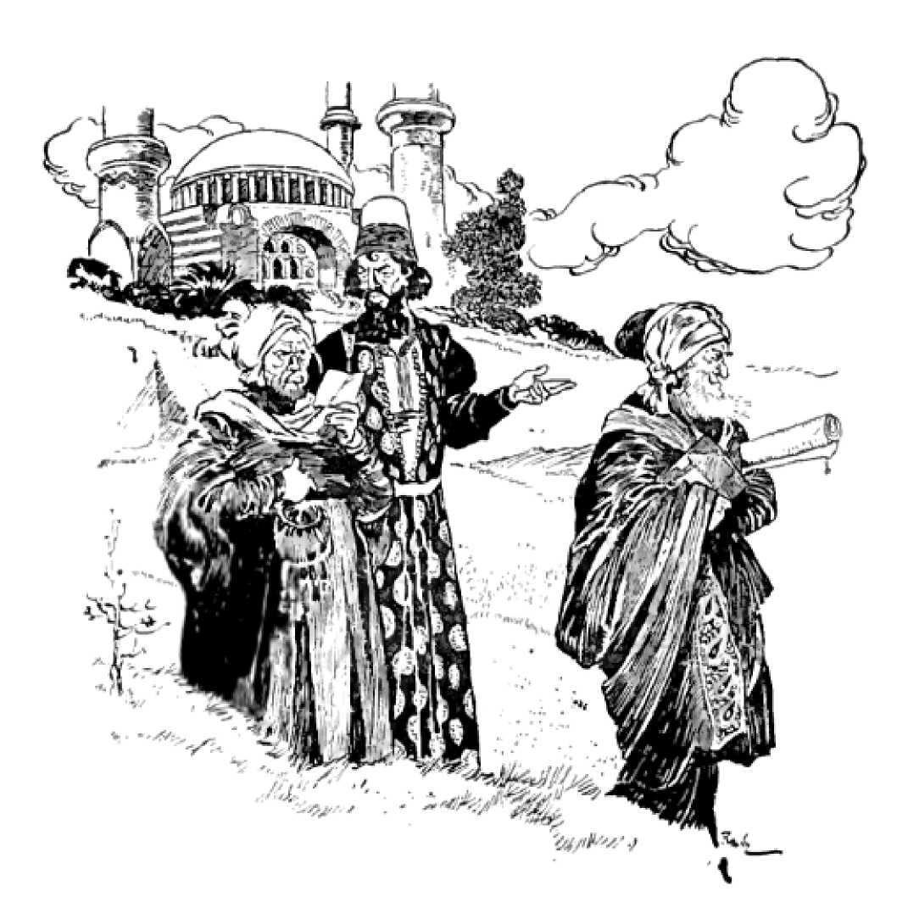EXAMPLE: A singular, but non-authoritative, copy of the Necronomicon would have a literary value of (20gp/page x 600 pages) 1,200gp. Added to its production value of 300gp, it would be worth 1,500gp.

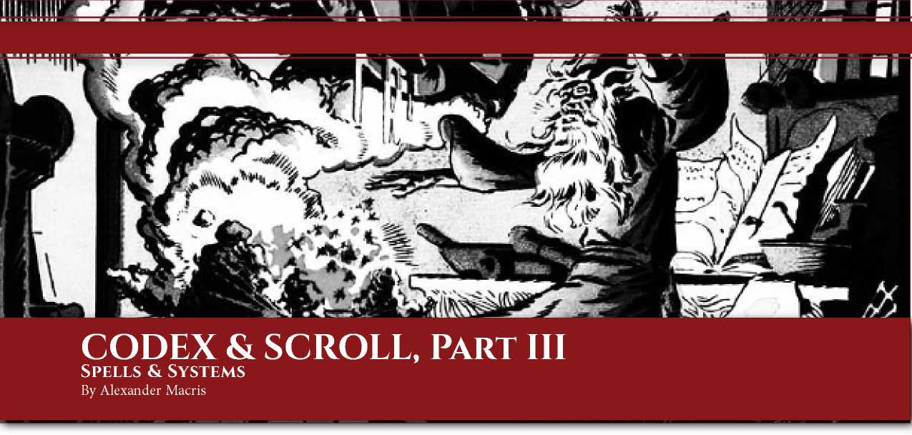*Make a small image of yellow wax, in the form of a man, in the month January and in the day and hour of Saturn, and at that time write with a needle above the crown of its head and upon its skull which thou shalt have adroitly raised, the character following... After which thou shalt replace the skull in proper position. Thou shalt then write upon a small strip of the skin of a frog or toad which thou shalt have killed, the following words and characters.. Thou shalt then go and suspend the said figure by one of thy hairs from the vault ofa cavern at the hour of midnight, and perfuming it with the proper incense thou shalt say. -* “Of the Experiment of Invisibility and How It Shall be Performed,” Chapter X, The Key of Solomon

Spell Formulae

Some books may include spell formulae and are known as **spell books**. The value of a spell book is based on its production value plus its literary value. For a book containing purely spells, both values are determined by the total value of the spell formulae contained within the book. When another type of book includes one or more spell formula, simply add the value of each spell formula to the value of the book. The Spell Formula Value table shows the value of a spell formula of each level. “Standard” spell formula are those found in *ACKS Core Rules, Player’s Companion,* and/or *Heroic Fantasy Handbook.* “Custom” spell formula are one-of-a-kind finds in hand-placed treasure hoards or created for particular PC or NPC repertoires in a campaign.

|  |  |  |
| --- | --- | --- |
| Spell Level | Stand. Formula | Custom Formula |
| 1 | 50gP | 2,000gp |
| 2 | 100gp | 3,500gp |
| 3 | 200gp | 4,500gp |
| 4 | 500gp | 5,500gp |
| 5 | 1,500gp | 6,100gp |
| 6 | 3,500gp | 7,000gp |
| 7 | 5,500gp | 8,100gp |
| 8 | 7,500gp | 10,000gp |
| 9 | 11,000gp | 11,000gp |

Production and Literary Value Calculations A blank spell book has 100 pages of parchment and costs 20gp. We assume spell books all use fine parchment costing (at 8cp per page) a total of 8gp. If the spell book is a codex, we assume a treasure-bound cover costing 1d10gp, metallic cover clasps costing 1d10gp, and fancy cover straps costing 1gp for a total average cost of 20gp. If the spell book is a scroll roll, we assume silver, ivory, or gold handles costing 2d10gp, and a wooden scroll box costing 1gp, for a total average cost of 20gp. This yields an average cost per blank page of 2sp (.2gp x 100 pages = 20gp), which is counted as part of production value. (Given the general values of spell books, this amount is so low as to be a rounding error but it’s included for the sake of completeness.)

In addition, however, there is a cost associated with actually inscribing the formula onto the pages. Each spell formula in a book takes up one page per spell level (e.g. one page each for 1st level spells, two pages for 2nd level spells, and so on). Ordinary books have a production cost of 4sp per page for scribing, illuminating, and binding. However, spell formulae require the knowledge and use of various rare inks, pigments, and quills. These create a flat cost of 50gp per page.

NOTE: Shouldn’t the cost of 50gp per page should actually vary based on the scribe’s ranks in Craft (scribing) or Art (calligraphy)? After all, the monthly wage of a craftsman (10gp, 20gp, 40gp, or 80gp) would, at 12 months per year and 300 pages per year, yield a cost of 4sp to 32sp per page. For simplicity, we have assumed that the cost of inks, pigments, and quills is (50gp per page) - (scribe’s cost per page). The in­world assumption is that untrained or low-rank scribes make frequent errors that are very costly in raw materials. Thus a mage without Craft (scribing) pays 50gp per page in raw materials, while a master scribe can accomplish the same work for 46gp, 8sp in raw materials.

The literary value of a spell formula is based on the level of the spell it describes. Given the default assumptions of *ACKS,* we know that (1) spellcasters must perform spell research to learn new spells if they do not have the spell’s formulae; (2) only high-level spellcasters know high level spells; (3) even higher-level spellcasters know more spells of low level than high-level spells; (4) higher- level spellcasters are much, much rarer than low-level spellcasters. As a result, the number of low-level spells in circulation is of a vastly higher order of magnitude than the number of high-level spells. These assumptions drive the calculations that follow, which use the opportunity cost of researching a spell as the base literary value of the formula, which is then adjusted by its rarity modifier.

The Total Copies of Individual Spell Formula of Each Spell Level table, below, shows the total population of arcane and/or eldritch spellcasters throughout the known world of the Auran Empire campaign setting, along with the number of spells known of each level known by those spellcasters and the total copies of each individual spell formula (e.g. **magic missile**, **sleep**, etc.). Note that some values are rounded, and the table assumes that spellcasters have an average INT 13 and that there are 24 spells known to exist of each level. We also assume that the rate of decay and loss of spell formula is approximately equal to their rate of creation.

|  |  |  |  |  |  |  |  |  |  |  |  |  |  |  |  |  |  |  |  |
| --- | --- | --- | --- | --- | --- | --- | --- | --- | --- | --- | --- | --- | --- | --- | --- | --- | --- | --- | --- |
| Caster  Level | Total Pop. | Spells Known per Caster | | | | | | | | | Total Spells Known | | | | | | | | |
| 1 | 2 | 3 | 4 | 5 | 6 | 7 | 8 | 9 | 1 | 2 | 3 | 4 | 5 | 6 | 7 | 8 | 9 |
| 1 | 157,647 | 2 | 0 | 0 | 0 | 0 | 0 | 0 | 0 | 0 | 315,294 | 0 | 0 | 0 | 0 | 0 | 0 | 0 | 0 |
| 2 | 57,326 | 3 | 0 | 0 | 0 | 0 | 0 | 0 | 0 | 0 | 71,979 | 0 | 0 | 0 | 0 | 0 | 0 | 0 | 0 |
| 3 | 20,846 | 3 | 2 | 0 | 0 | 0 | 0 | 0 | 0 | 0 | 62,538 | 41,692 | 0 | 0 | 0 | 0 | 0 | 0 | 0 |
| 4 | 7,580 | 3 | 3 | 0 | 0 | 0 | 0 | 0 | 0 | 0 | 22,741 | 22,741 | 0 | 0 | 0 | 0 | 0 | 0 | 0 |
| 5 | 3,446 | 3 | 3 | 2 | 0 | 0 | 0 | 0 | 0 | 0 | 10,337 | 10,337 | 6,891 | 0 | 0 | 0 | 0 | 0 | 0 |
| 6 | 2,005 | 3 | 3 | 3 | 0 | 0 | 0 | 0 | 0 | 0 | 6,014 | 6,014 | 6,014 | 0 | 0 | 0 | 0 | 0 | 0 |
| 7 | 729 | 4 | 3 | 3 | 2 | 0 | 0 | 0 | 0 | 0 | 2,916 | 2,187 | 2,187 | 1,458 | 0 | 0 | 0 | 0 | 0 |
| 8 | 265 | 4 | 4 | 3 | 3 | 0 | 0 | 0 | 0 | 0 | 1,060 | 1,060 | 795 | 795 | 0 | 0 | 0 | 0 | 0 |
| 9 | 96 | 4 | 4 | 4 | 3 | 2 | 0 | 0 | 0 | 0 | 386 | 386 | 386 | 289 | 193 | 0 | 0 | 0 | 0 |
| 10 | 61 | 4 | 4 | 4 | 4 | 3 | 0 | 0 | 0 | 0 | 245 | 245 | 245 | 245 | 184 | 0 | 0 | 0 | 0 |
| 11 | 22 | 5 | 4 | 4 | 4 | 3 | 2 | 2 | 2 | 2 | 112 | 89 | 89 | 89 | 67 | 45 | 45 | 45 | 45 |
| 12 | 8 | 5 | 5 | 4 | 4 | 4 | 3 | 2 | 2 | 2 | 41 | 41 | 32 | 32 | 32 | 24 | 16 | 16 | 16 |
| 13 | 3 | 5 | 5 | 5 | 4 | 4 | 3 | 2 | 2 | 2 | 15 | 15 | 15 | 12 | 12 | 9 | 6 | 6 | 6 |
| 14 | 1 | 5 | 5 | 5 | 5 | 4 | 4 | 2 | 2 | 2 | 5 | 5 | 5 | 5 | 4 | 4 | 2 | 2 | 2 |
| Total | 250,036 |  |  |  |  |  |  |  |  |  | 593,682 | 84,812 | 16,660 | 2,927 | 492 | 82 | 69 | 69 | 69 |
| Total Copies of Each Individual Spell Formula of Each Spell Level | | | | | | | | | | | 24,736 | 3,533 | 694 | 122 | 20 | 4 | 3 | 3 | 3 |

The Recommended Value of Spell Formula by Spell Level table, below, shows how the output of the prior table can be used to develop a value for a spell formula in a spell book.

|  |  |  |  |  |  |  |  |  |  |
| --- | --- | --- | --- | --- | --- | --- | --- | --- | --- |
| Spell Level | 1 | 2 | 3 | 4 | 5 | 6 | 7 | 8 | 9 |
| Total Copies of Each Spell Formula of Each Spell Level | 24,736 | 3,533 | 694 | 122 | 20 | 4 | 3 | 3 | 3 |
| Rarity Mod. of Each Spell Formula of Each Spell Level | 0 | 0 | 1% | 5% | 25% | 50% | 65% | 75% | 100% |
| Base Cost of Spell Research by Spell Level | 1,818 | 3,333 | 4,286 | 5,333 | 5,882 | 6,667 | 7,778 | 9,412 | 10,588 |
| Modified Cost of Spell Research by Spell Level | 0 | 0 | 43 | 266 | 1,470 | 3,333 | 5,133 | 7,060 | 10,588 |
| Cost of Production by Spell Level | 50.2 | 100.4 | 150.6 | 200.6 | 251 | 301.2 | 351.4 | 401.6 | 451.8 |
| Calculated Value of Spell Formula by Spell Level | 50.2 | 100.4 | 193.6 | 466 | 1,721 | 3,634 | 5,483 | 7,460 | 11,039 |
| Recommended Value of Spell Formula by Spell Level | 50 | 100 | 200 | 500 | 1,500 | 3,500 | 5,500 | 7,500 | 11,000 |
| Rec. Value of Custom Spell Formula by Spell Level | 2,000 | 3,500 | 4,500 | 5,500 | 6,100 | 7,000 | 8,100 | 10,000 | 11,000 |

The rarity modifier is based on the total copies of each spell formula of each spell level (modified from those used for ordinary books). The base cost of spell research by spell level is calculated by using 1,000gp per spell level and dividing it by the expected chance of success for a minimum-level caster of that spell level under ideal conditions (maximum INT, library bonus, and proficiency bonus). The base cost is then multiplied by the rarity modifier, and the product added to a cost of production of 50gp per spell level. The recommended values are rounded to offer a smoother simplified progression.

If the Judge’s campaign uses different assumptions, then the data above can be adjusted to reach a different the outcome. For instance, if spellcasters are half as common, then the total copies of each formula will be halved, and the rarity modifiers will be higher. If spell formula don’t require rare inks and materials, the cost of production could be reduced to 10gp per page, 5gp per page, or even less.

EXAMPLE: By default, there are 492 copies of 5th level spell formulas in the known world, with 20 copies of each of the 24 known spells. (Note that 20 is not an exact fit in that 24 x 20 = 480; but 24 x 21 = 504 so it’s the best whole number.) Let’s imagine, however, that a terrible magic plague killed off all of the wizards of 10th level and above, consuming their spell books in the process. This would leave only 193 copies of 5th level spell formulas existent, suggesting that perhaps the rarity modifier should be 33% instead of 25%.

**Ritual Spells:** In the *ACKS Core Rules,* there is no provision made for learning ritual spells from spell formulae. However, when using these rules, a ritual spell can be learned from its spell formulae. The cost of ritual spell formulae (or their value as treasure) is sufficiently high that game balance is preserved.

Research Formulae

In addition to spell books, characters might find **research formula books** which contain one or more formulae useful for magic research. As always the value of a research formula book is based on its production value plus its literary value. For a book containing purely research formulae, both values are determined by the total value of the spell formulae contained within the book. When another type of book includes one or more research formula, simply add the value of each research formula to the value of the book. The Research Formula Value table (on the bottom ofp. 23) shows the value of a spell formula of each level as a percentage of item value.

EXAMPLE: A **potion of healing** has abase cost of 500gp. The formula for a potion of healing has a value of (500gp x 10%) 50gp. A **sword+1** has a base cost of 10,000gp. The formula for a sword +1 has a value of (10,000gp x 25%) 2,500gp.

NOTE: A formula reduces the base cost and special component cost of an item or other research project by half each. Therefore, all other things being equal, buyers would pay up to the amount, e.g. У2 base cost + У2 special component cost of the item. However, formulae can be copied without impairing their use, so a seller can sell a formulae while still retaining a copy for himself. Thus we assume the number of sellers will be in excess and reduce the value of the formulae. The item’s base cost stands in as a proxy for rarity because (as shown in the *ACKS Magic Item Transactions by Market Class* table), price determines number available for sale.

Random Rare Book Generation

The Judge can use the following procedure to randomly generate a rare book to place in a library, treasure hoard, or other venue. The table is structured such that it produces results that align with *ACKS* demographic assumptions (e.g. number of characters with 18 INT, number of rank 4 proficiency holders, etc.). The output has been calibrated so that the average book yields a value equal to that of the “rare book” commodity (300gp per stone0, so a bundle of randomly generated books can be placed in a hoard seamlessly.

RANDOM RARE BOOK GENERATION PROCEDURE

1. Roll IdlOOO for topic on the Random Book Topic table.
2. Roll IdlOO for scope on the Random Book Scope table.
3. Roll IdlOO for complexity on the Random Book Complexity by Scope table.
4. Roll IdlOO for language on the Random Book Language table.
5. Roll IdlOO for age on the Random Book Age by Language table.
6. Roll IdlOO for format on the Random Book Format by Age table.
7. Roll IdlOO for page materials on the Random Book Material by Format table.
8. Roll IdlOO for number of existent copies on the Random Number of Copies table.
9. Calculate page length as (scope x 1000) *I* complexity.
10. Calculate reading/reference time as page length *I* 180.
11. Calculate production value based on page length and book page materials.
12. Calculate base literary value based on page length, scope, and complexity.
13. Calculate rarity modifier based on number of existent copies.
14. Calculate modified literary value based on base literary value and rarity modifier.
15. Calculate book value by adding production value plus modified literary value. Add in authority value, if any.
16. Calculate book weight based on page materials.
17. Calculate number of volumes based on page length and format. Codices must be divided into volumes every 750 pages, scrolls must be divided into volumes every 250 pages. Add 1.5 lbs weight per codex volume and 2 lbs weight per scroll volume.

**Authority:** If the topic rolled in step 1 is an authority, roll again to determine the topic of its authority. On a re-roll of 901 or higher, select a spell type or magic research. If the scope rolled is 2 or less, raise it to 3. If the complexity rolled is 2 or less, raise it to 3. The authority’s rank will be equal to its complexity - 2.

EXAMPLE: The Judge gets the surprising result of 1000 in step 1, so the random book is an authority! He rolls again for a new topic, resulting in 329 - Craft (weapon-smithing). In step 2, he rolls a 40, so the scope is 1; since it’s an authority it’s raised to 3. In step 3 he rolls a 37, so the complexity is 3. The authority’s rank is +1.

**Esoteric Books:** If the topic rolled in step 1 is an esoteric topic, roll again for the book’s apparent topic. Re-roll repeated esoteric results. The scope determined in step 2 will be the esoteric scope, and the complexity in step 3 will be the esoteric complexity. The apparent scope / apparent complexity) should be set by the Judge to equal or exceed (esoteric scope / esoteric complexity).

**Scope Exceeding Topic:** If the proficiency rolled does not afford the opportunity to be selected enough times to meet the scope rolled, the Judge has two options. He can reduce the scope to 1, or he can roll for or choose an additional topic or topic(s) until enough proficiency ranks are available to equal the scope.

EXAMPLE: The Judge rolls a 126 for topic - Black Lore of Zahar. He rolls an 81 for scope, for a scope of 3. A character cannot take two or more ranks in Black Lore of Zahar. The Judge can choose to either reduce the book to a scope of 1, or add other ranks in other proficiencies. He decides to add Collegiate Wizardry 2 to the book.

w

**Sub-Specializations:** The Judge may choose to replace one or more ranks in a topic with twice as many ranks in a sub­specialization. No topic may have more than four ranks.

EXAMPLE: In the example above, the Judge could replace | Collegiate Wizardry 2 with Collegiate Wizardry (sorcery of j Zahar) 4.

Example of Random Book Generation

The Judge decides that rather than put a generic rare book in a treasure hoard he will randomly generate a specific book.

First, the Judge rolls for a topic on the Random Book Topic table. The result is an 014 so the topic of the book is Alchemy. Now the Judge rolls for scope on the Random Book Scope table. The roll is 71, so the book’s scope is 2. Rolling for complexity on the Random Book Complexity by Scope table, gets a 62, so the book’s complexity is 3.

Now the Judge rolls for language on the Random Book Language table. The result is a 79, so the book is written in a regional language. The treasure hoard is guarded by a rakshasa, so the Judge decides the language is Somirean. Next the Judge rolls for age on the Random Book Age by Language table. The roll is a 68, so the book is 31 - 50 years old. It’s been around for about two generations.

Item Base Cost Formula Value

|  |  |
| --- | --- |
| 100gp | 5% |
| 101gp to 1,000gp | 10% |
| 1,001gp to 10,000gp | 25% |
| 10,001gp or more | 50% |

Next the Judge rolls for format on the Random Book Format by Age table. Given its age, it’s almost certainly a codex. A roll of 98 confirms it. Rolling for page material on the Random Book Material by Format table, the Judge gets a 64, so the book is parchment. Rolling for number of existent copies on the Random Number of Copies table, the Judge gets a 17. There are only 2 to 5 copies of this book in circulation, so it has a rarity modifier of 50%!

With all the random rolls handled, the Judge now calculates the book’s characteristics. Using the formula page length = (scope x 1000) / complexity, he calculates a page length of 667 pages. Using the formula reading time = page length / 180, he calculates a reading time of 3.7 days, which rounds to 4 days.

As a parchment codex, the book has a 37cp production value per page. At 667 pages, that is 246.79gp. For simplicity, the Judge rounds this to 247gp. As a book with scope 2, complexity 3, the book has a base literary value of 2.5gp per page. At 500 pages, that is 1,250gp. Applying the rarity modifier of 50% yields a modified literary value of 625gp. The book’s total value is therefore 247gp + 625gp, or 872gp. With just 667 pages, the book fits into one volume. Therefore the book’s weight is (667 x .06) 40.2 lbs + 1.5 lbs for the cover, or 42.7 lbs. At 1 st per 15 lbs, that is 2 5/6 st. It is worth (872gp / 2.84 st) = 307gp per stone, right in the range we expect for rare books.

The Judge decides the author will be named Kandahar and the book titled *Complex Catalyzation Using the Alchemical Arts*. The final book is therefore recorded in the treasure hoard as Kandahar’s *Complex Catalyzation Using the Alchemical Arts* (Parchment codex, Volumes: 1, Scope: Alchemy 2, Complexity: 3, Language: Somirean, Pages: 667, Reading Time: 4 days, Value: 347gp, Weight: 42.7 lbs).

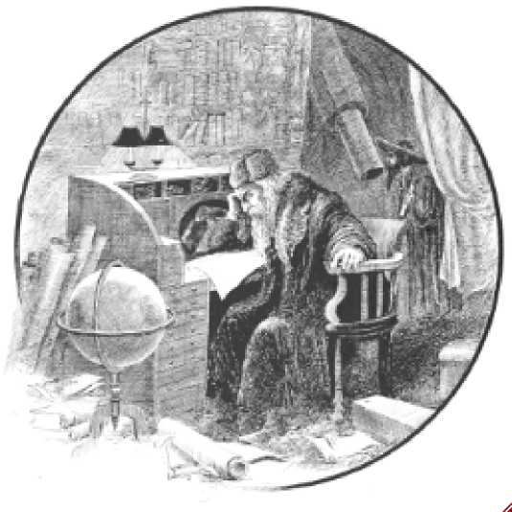

|  |  |  |  |  |  |
| --- | --- | --- | --- | --- | --- |
| 01-05 | Acrobatics | 316-320 | Craft (tinkering) | 631-635 | Naturalism |
| 06-10 | Alchemy | 321-325 | Craft (weaving) | 636-640 | Naturalism |
| 11-15 | Alchemy | 326-330 | Craft (weaponsmithing) | 641-645 | Navigation |
| 16-20 | Alertness | 331-335 | Craft (wheelwright) | 645-650 | Navigation |
| 21-25 | Ambushing | 336-340 | Diplomacy | 651-655 | Pass Without Trace |
| 26-30 | Animal Husbandry | 341-345 | Disguise | 656-660 | Performance (acting) |
| 31-35 | Animal Training (dogs) | 345-350 | Dungeon Bashing | 661-665 | Performance (chanting) |
| 36-40 | Animal Training (horses) | 351-355 | Dwarven Brewing | 666-670 | Performance (dancing) |
| 41-45 | Animal Training (falcons) | 356-360 | Eavesdropping | 671-680 | Performance (epic poetry) |
| 45-50 | Apostasy | 361-365 | Elementalism | 681-685 | Performance (playing instruments) |
| 51-55 | Arcane Dabbling | 366-370 | Endurance | 686-690 | Performance (singing) |
| 56-60 | Art (calligraphy) | 371-380 | Engineering | 691-695 | Performance (storytelling) |
| 61-65 | Art (drawing) | 381-385 | Engineering | 696-700 | Precise Shooting |
| 66-70 | Art (illumination) | 386-390 | Familiar | 701-705 | Prestidigitation |
| 71-80 | Art (mosaic) | 391-395 | Fighting Style | 706-710 | Profession (actuary) |
| 81-85 | Art (painting) | 396-400 | Gambling | 711-715 | Profession (banker) |
| 86-90 | Art (sculpture) | 401-405 | Goblin-Slaying | 716-720 | Profession (chamberlain) |
| 91-95 | Art (stained glass) | 406-410 | Healing | 721-725 | Profession (judge) |
| 96-100 | Bargaining | 411-415 | Healing | 726-730 | Profession (lawyer) |
| 101-105 | Battle Magic | 416-420 | Healing | 731-735 | Profession (librarian) |
| 106-110 | Battle Magic | 421-425 | Illusion Resistance | 736-740 | Profession (merchant) |
| 111-115 | Beast Friendship | 426-430 | Intimidation | 741-745 | Profession (restaurateur) |
| 116-120 | Berserkergang | 431-435 | Knowledge (architecture) | 745-750 | Profession (seneschal) |
| 121-125 | Black Lore of Zahar | 436-440 | Knowledge (astrology) | 751-755 | Profession (torturer) |
| 126-130 | Black Lore of Zahar | 441-445 | Knowledge (geography) | 756-760 | Prophecy |
| 131-135 | Blind Fighting | 446-450 | Knowledge (history) | 761-765 | Quiet Magic |
| 136-140 | Bribery | 451-455 | Knowledge (mathematics) | 766-770 | Riding |
| 141-145 | Caving | 456-460 | Knowledge (natural history) | 771-780 | Righteous Turning |
| 145-150 | Cat Burglary | 461-465 | Knowledge (natural philosophy) | 781-785 | Running |
| 151-155 | Climbing | 466-470 | Knowledge (political economy) | 786-790 | Seafaring |
| 156-160 | Collegiate Wizardry | 471-480 | Knowledge (occult) | 791-795 | Seafaring |
| 161-165 | Collegiate Wizardry | 481-485 | Knowledge (trivia) | 796-800 | Seduction |
| 166-170 | Combat Reflexes | 486-490 | Labor (barber) | 801-805 | Siege Engineering |
| 171-180 | Combat Trickery | 491-495 | Labor (bricklaying) | 806-810 | Siege Engineering |
| 181-185 | Command | 496-500 | Labor (butchering) | 811-815 | Signaling |
| 186-190 | Contemplation | 501-505 | Labor (construction) | 816-820 | Skirmishing |
| 191-195 | Contortionism | 506-510 | Labor (domestic) | 821-825 | Skulking |
| 196-200 | Craft (armor-making) | 511-515 | Labor (farming) | 826-830 | Sniping |
| 201-205 | Craft (baking) | 516-520 | Labor (mining) | 831-835 | Soothsaying |
| 206-210 | Craft (basket-making) | 521-525 | Labor (shepherding) | 836-840 | Survival |
| 211-215 | Craft (blacksmithing) | 526-530 | Labor (stone-cutting) | 841-845 | Swashbuckling |
| 216-220 | Craft (book-binding) | 531-535 | Land Surveying | 845-850 | Theology |
| 221-225 | Craft (bow-making) | 536-540 | Laying on Hands | 851-855 | Theology |
| 226-230 | Craft (brewing) | 541-545 | Leadership | 856-860 | Theology |
| 231-235 | Craft (candle-making) | 545-550 | Lip Reading | 861-865 | Trap Finding |
| 236-240 | Craft (carpentry) | 551-555 | Lockpicking | 866-870 | Tracking |
| 241-245 | Craft (cobbling) | 556-560 | Loremastery | 871-880 | Transmogrification |
| 245-250 | Craft (cooking) | 561-565 | Loremastery | 881-885 | Trapping |
| 251-255 | Craft (doll-making) | 566-570 | Magical Engineering | 886-890 | Unflappable Casting |
| 256-260 | Craft (dying) | 571-580 | Magical Engineering | 891-895 | Weapon Finesse |
| 261-265 | Craft (embroidery) | 581-585 | Magical Music | 896-900 | Weapon Focus |
| 266-270 | Craft (fletching) | 586-590 | Manual of Arms | 901-910 | Esoteric: Alchemy |
| 271-280 | Craft (leatherworking) | 591-595 | Manual of Arms | 911-920 | Esoteric: Apostasy |
| 281-285 | Craft (lock-smithing) | 596-600 | Mapping | 921-930 | Esoteric: Black Lore of Zahar |
| 286-290 | Craft (rune-carving) | 601-605 | Mapping | 931-940 | Esoteric: Knowledge (occult) |
| 291-295 | Craft (saddlery) | 606-610 | Martial Training | 941-950 | Esoteric: Loremastery |
| 296-300 | Craft (scribing) | 611-615 | Military Strategy | 951-960 | Esoteric: Soothsaying |
| 301-305 | Craft (scrivening) | 616-620 | Military Strategy | 961-970 | Esoteric: Theology |
| 306-310 | Craft (stonemason) | 621-625 | Mimicry | 971-999 | Esoteric: Judge’s Choice |
| 311-315 | Craft (tanning) | 626-630 | Mountaineering | 1000 | Authority. |

Book Topic

Book Topic

Book Topic

Roil

Roil

Roil



Random Book Language

|  |  |
| --- | --- |
| Roll1d00 | Language |
| 01-30 | Classical (Classical Auran or equivalent imperial-ecclesiastic language such as Latin) |
| 31-65 | Common (Common Auran or equivalent trade language such as Koine Greek) |
| 66-85 | Regional (Nicean, Krysean, Somirean, etc., or equivalent regional language such as Thracian) |
| 86-90 | Dwarven (Meniri or Jutlandic Dwarven or equivalent demihuman tongue) |
| 91-95 | Elven (ArgoUc'an or equivalent demihuman tongue) |
| 95-100 | Ancient (Ancient Zaharan or equivalent ill-remembered foreign tongue such as Sumerian) |

Random Book Age by Language

Book AgE

|  |  |  |  |  |  |  |  |  |
| --- | --- | --- | --- | --- | --- | --- | --- | --- |
| Book Language | io years or less | 11-30 years | 31-50 years | 51-100 years | 101-500 years | 501-1,000 years | 1,000-2,000 years | 2,000 years or more |
| Classical | 01-05 | 06-20 | 21-35 | 36-75 | 76-95 | 96-100 | - | - |
| Common | 01-05 | 06-25 | 26-75 | 76-95 | 96-100 | - | - | - |
| Regional | 01-05 | 06-25 | 26-75 | 76-100 | - | - | - | - |
| Dwarven | 01-05 | 06-15 | 16-30 | 31-50 | 51-75 | 76-95 | 96-99 | 100 |
| Elven | 01-05 | 06-10 | 11-20 | 21-40 | 41-60 | 61-80 | 81-95 | 96-100 |
| Ancient | 01-05 | 06-10 | 11-15 | 16-20 | 21-30 | 31-70 | 71-90 | 91-100 |

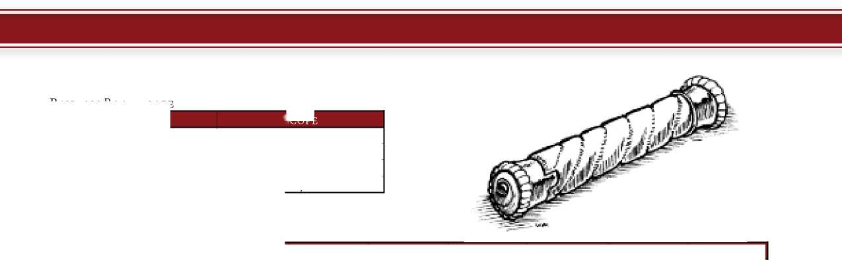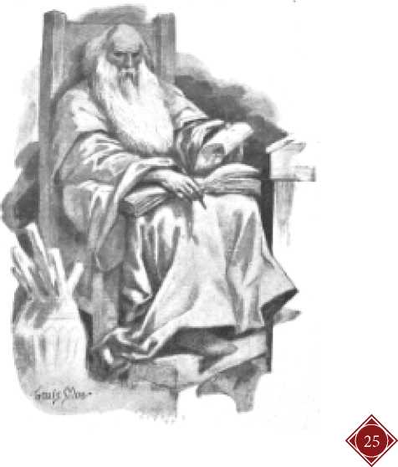

Random Book Scope

Roll idioo

| 01-55 | 1 |
| --- | --- |
| 56-80 | 2 |
| 81-95 | 3 |
| 96-100 | 4 |

Scope

| Book Scope | 0.75 | 1 |  | **n** | **n** |  | 6 | 7 |
| --- | --- | --- | --- | --- | --- | --- | --- | --- |
| 1 | 01-25 | 26-50 | 51-91 | 92-99 | 100 | - | - | - |
| 2 | 01-06 | 07-21 | 22-61 | 62-91 | 92-99 | 100 | - | - |
| 3 | 01 | 02-06 | 07-21 | 22-61 | 62-91 | 92-99 | 100 | - |
| 4 | 01 | 02-06 | 07-11 | 12-26 | 27-59 | 60-91 | 92-99 | 100 |

Random Book Complexity by Scope

| 10 years or less | 01 | 02 | 03-100 |
| --- | --- | --- | --- |
| 11-50 years | 01 | 02-03 | 04-100 |
| 51-100 years | 01 | 02-05 | 06-100 |
| 101-500 years | 01 | 02-25 | 26-100 |
| 501-1,000 years | 01-05 | 06-80 | 81-100 |
| 1,000-2,000 years | 01-25 | 26-75 | - |
| 2,000 years or more | 01-50 | 51-100 | - |

Random Book Format by Age

Book Age Tablet Scroll Codex

Random Book Material by Format

| Die Roll Number of Copies Extant | | Rarity Modifier |
| --- | --- | --- |
| 01-10 | 1 | 100% |
| 11-25 | 2 to 5 | 50% |
| 26-50 | 6 to 25 | 33% |
| 51-65 | 26 to 50 | 25% |
| 66-75 | 51 to 100 | 10% |
| 76-85 | 101 to 250 | 5% |
| 86-90 | 251 to 500 | 2% |
| 91-95 | 501 to 1,000 | 1% |
| 96-100 | 1,000 or more | 0% |

Random Book Rarity

|  |  |  |  |  |  |  |  |  |  |
| --- | --- | --- | --- | --- | --- | --- | --- | --- | --- |
| Book Type | Stone | Clay | Gold Foil | Silver Foil | Copper Foil | Vellum | Parchment | Fine Papyrus | Papyrus |
| Tablet | 01-20 | 21-80 | 81 | 82-85 | 86-100 | - | - | - | - |
| Scroll | - | - | - | - | - | 01-20 | 21-50 | 51-70 | 71-100 |
| Codex | - | - | 01 | 02-03 | 04-05 | 06-50 | 51-100 | - | - |

Book Production Value by Format and Material

Book Material Cost per Page (Codex) Cost (Scroii/TaBiEt) Weight (Scroll)

|  |  |  |  |
| --- | --- | --- | --- |
| Parchment, ordinary, 0.01” thick | 37cp / page | 36cp / page | 0.06 lbs / page |
| Parchment, fine (vellum), .01” thick | 39cp / page | 38cp / page | 0.06 lbs / page |
| Copper foil, .005” thickness | 43cp / page | 42cp / page | 0.12 lbs / page |
| Silver foil, .005” thickness | 181cp /page | 180cp / page | 0.15 lbs / page |
| Gold foil, .005” thickness | 3031cp / page | 3030cp / page | 0.30 lbs / page |
| Papyrus, ordinary, 0.01” thick | - | 31cp / page | 0.06 lbs / page |
| Papyrus, fine, 0.01” thick | - | 33cp / page | 0.06 lbs / page |
| Clay tablet, 0.125” thickness | - | 80cp / page | 0.75 lbs / page |
| Stone tablet, 0.125” thickness | - | 130cp / page | 1 lbs / page |

Book Literary Value By Scope and Complexity

|  |  |  |  |  |  |  |  |  |
| --- | --- | --- | --- | --- | --- | --- | --- | --- |
| Book Scope | Book Complexity | | | | | | | |
| **0.75** | **1** | **2** | **3** | **4** | **5** | **6** | **7** |
| 1 | 1 | 1 | 1.25 | 2 | 5 | N/A | N/A | N/A |
| 2 | 2 | 2 | 2 | 2.5 | 4 | 10 | N/A | N/A |
| 3 | 4 | 4 | 4 | 4 | 5 | 8 | 20 | N/A |
| 4 | 10 | 10 | 10 | 10 | 10 | 12.5 | 20 | 50 |

